Зразки модульних та залікових питань до курсу «Іноземна мова за професійним спрямуванням» для магістрів спеціальності «Маркетинг»

Speaking
In the speaking task, you need to give a well-structured and clear no less than 1-minute monologue on ONE of the issues mentioned below. Your performance is evaluated according to the following criteria: relevance of the content, accuracy of the language and vocabulary, fluency of expression, coherence and cohesion of the monologue produced. Comment on the following issues:
- How would you define ‘branding’ and why is it important in modern marketing?
- What are the key differences between traditional and digital marketing? Which do you think is more effective today?
- Can you explain the concept of a Unique Selling Proposition (USP)? Give an example of a brand with a strong USP.
- What role does storytelling play in marketing, and how can brands use it to connect with consumers?
- Discuss the importance of market segmentation. How can businesses benefit from segmenting their target audience?
- How does consumer psychology influence purchasing decisions? Can you give an example?
- What is neuromarketing, and how can companies use it to improve advertising effectiveness?
- Why do consumers develop brand loyalty? Can you think of a brand with a strong customer following?
- How do emotions impact consumer decisions? Give an example of a successful emotional marketing campaign.
- What are the key differences between *B2B (business-to-business) and B2C (business-to-consumer) marketing?
- How has social media changed the way businesses market their products? What are the advantages and disadvantages?
- Discuss the role of influencer marketing in today’s business world. Is it always effective? Why or why not?
- What are the key elements of an effective content marketing strategy? Provide an example of a brand using content marketing successfully.
- How do search engine optimization (SEO) and pay-per-click (PPC) advertising help businesses grow online?
- How should companies handle negative online reviews and customer complaints on social media?
- How is artificial intelligence (AI) influencing modern marketing strategies? Can you think of a company using AI effectively?
- What are the biggest emerging trends in marketing for the next five years?
- How important is corporate social responsibility (CSR) in marketing? Can it impact customer loyalty?
- With the rise of big data, how can marketers use analytics to improve their strategies?
- What ethical concerns should companies consider in marketing? Give an example of a marketing campaign that was criticized for ethical reasons.
- How much say should the stakeholders have in executive pay deals? What should the amount of the top executives’ salary depend on?
- Objectives-focused cultures clearly define objectives and detail roles and tasks in writing. Flexible cultures build relationships first and let goals develop with the relationship. What is common in your culture? How might this difference cause misunderstanding in multicultural teams?
- Think of any company in your country going offshore. Why does it happen? What are the potential benefits and risks for a company to go offshore? Provide examples. How does offshoring influence the national economy?
- In some cultures, senior managers make decisions and others carry out their instructions. In other cultures, decisions are made by consensus after everyone contributes suggestions and opinions. What is common in your country? How might this difference cause misunderstanding in multicultural teams?

Language and Vocabulary Test _{[20 pts]}

Part 1. Choose ONE correct answer and write it in the column on the right [Max. 15 pts]. |  |  |  |  | Your answer
1 |  | Which of the following words means to give tasks at work to other people?  - encourage  - delegate  - objectives
2 |  | Complete the sentence: It would be a great help if you ... get the report done by Friday. A will B could C can
3 |  | If a company’s debts have soared in the past year, they … A owe much more money than before.  B have made enormous profits. C have not really changed at all.
4 |  | Which of the following refer to the future of business?  - current trends  - economic forecasts C trends
5 |  | Which of the following describes an itinerary?  - a detailed business plan  - a schedule for an event or business trip C a list of the company’s assets
6 |  | If your business strategy is acquisition-based, you concentrate on … A buying.  - selling.  - advertising.
7 |  | What is a golden parachute?  - a substantial sum of money paid when you leave a company  - the money you receive every month on retirement C money put by for a rainy day
8 |  | The shareholders have called for the chairman to … following the financial scandals. A call off  - step down  - go under
9 |  | If a pay-package is linked to performance … A It is based on your work record.  - It is based on seniority.  - It is based on age.
10 |  | What is Gross Domestic Product (GDP)?  - the total imports of a country  - the value of the goods and services produced by a country C the money or income earned by a country in one year
11 |  | Complete the sentence: A foreign supplier was … the contract. A loaned
 |  |  | B benefited C awarded
 | 12 |  | What is the meaning of “to loan”?  - to give somebody something to keep  - to give somebody something on a temporary basis C to ask somebody to give you something
 | 13 |  | Offshoring means … A going global.  - re-locating.  - outsourcing overseas.
 | 14 |  | What is another term for Customer Support Service?  - R+D  - Help desk C HR
 | 15 |  | Which word is a synonym for redundant?  - laid off  - downsized  - outsourced
 |  |  |  | Total:

t | Part 2. Choose ONE correct answer from A, B, C, or D and write it in the column on he right [Max. 5 pts]. | Your answer
16 | This month we …………………………………………….. a lot of complaints about late deliveries. A receive  B received C have received D are receiving
17 | I can`t help ……………………………………………………..about what would lie in store for  Mark if he lost the job.  - worry  - worrying  - to worry  - to be worrying
18 | The price of cigarettes fell sharply when Phillip Morris ………………………………….. a price war, and it ……………………………. ever since.  - started/ fell  - started/ has fallen  - was started/ had fallen  - had started/ fell
19 | This time tomorrow I …………………………………………………. my presentation.  - will start  - will be starting  - am going to start  - start
20 | Have you had your accounts …………………………………………….? A check  - checking  - checked  - to have checked
 | Total:

Reading Comprehension
Read the article and decide whether these statements are true or false.
Write your answers here
- According to the article, family-run businesses can expect more long-term success than ones that aren’t owned and run by families.
- Only a small percentage of UK firms are family-owned.
- About one-sixth of the UK’s GDP comes from family-owned businesses.
- More than two-fifths of private-sector workers are employed by family-run businesses.
- One family-run UK company has been in business for more than 335 years.
- According to the article, there are far more disadvantages to family-run businesses than there are advantages.
- One of the main challenges faced by family-run firms is the conflict between the needs of the family and the needs of the business.
- Family-run businesses usually suffer because of the family’s emotional commitment to the business.
- Relatives are often given a job in a family business even when there are many more qualified people available to do the work.
- Non-family workers in a family-run business are usually less committed than people who work in companies that are not family-run.

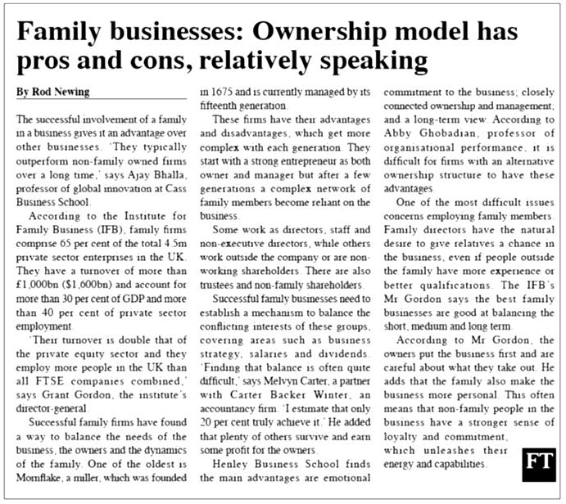

Listening Comprehension
1 | 2 | 3 | 4 | 5 | 6 | 7 | 8 | 9 | 10

- How many countries signed the free trade deal?
  - eight
  - twelve
  - fifteen
  - ten

- How many Southeast Asian nations signed the deal?
  - 10
  - 12
  - 15
  - 8

- How much of the global economy do the countries represent?
  - exactly 30%
  - just over 30%
  - just under 30%
  - around 30%

- When did talks about the deal first start?
  - 2011
  - 2012
  - 2013
  - 2014

- What positive thing did an economics expert say the region wants?
  - leadership
  - development
  - economic growth
  - profit

- What did China's premier say the negotiations brought?
  - profit
  - a ray of light
  - clean water
  - peace

- What did China's premier say multilateralism was?
  - a good idea
  - difficult
  - perfect
  - the right way

- What is going in the right direction, besides the global economy?
  - talks
  - humanity's progress
  - profit figures
  - the world

- What is the deal an ideal framework of, besides global trade?
  - investment
  - peace
  - negotiations
  - collaboration

- What kind of mix of economies did South Korea say the deal was?
  - a strange mix
  - an interesting mix
  - a perfect mix
  - a diverse mix

Затверджено на засіданні кафедри полікультурної освіти та перекладу
протокол № 2 від «26» вересня 2025 р.
Завідувач кафедри доц.Мишко С.А.

