SYNDROMIC DIAGNOSIS OF Chronic Hepatitis
Chronic hepatitis is a chronic diffuse or focal inflammatory affection of the liver.
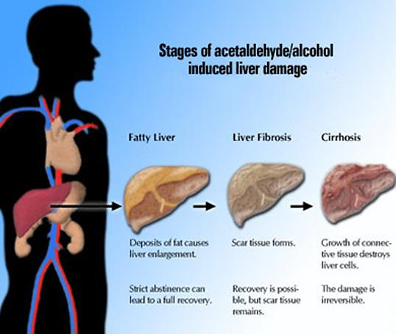
Aetiology. The following groups of chronic hepatitis are distinguished:
(1) infectious and parasitogenic; infectious hepatitis develops secondary to virus hepatitis, brucellosis, tuberculosis, syphilis, and some other diseases;
(2) toxic hepatitis caused by industrial, medicamentous, domestic and food chronic poisoning by hepatotropic toxic substances (chloroform, trinitrotoluene, aminazine, lead compounds, etc);
(3) toxico-allergic hepatitis, which develops not only in response to direct toxic effect of some medicines or hepatotropic chemicals, but also due to hypersensitivity of the liver cells of the entire body to these substances (medicamentous hepatitis, hepatitis associated with collagenosis);
(4) metabolic hepatitis, which arises due to metabolic disorders in the liver, associated with protein-vitamin deficiency, and also in fat dystrophy and amyloidosis.
In 40—70 per cent of cases chronic hepatitis develops as an outcome of an acute epidemic or serum hepatitis. Hepatitis is mostly diffuse affection of the liver. Liver affections are focal in tuberculosis (tuberculous granulomas, caseous abscesses or tuberculoma), syphilis (gumma), some protozoal disease (amoebic abscesses), fungal and bacterial affections (usually abscesses), and in some other cases.
Pathogenesis. This is mostly determined by the aetiology of the disease. When exposed chronically to hepatotropic toxic substances, the hepatocytes become progressively affected (to necrobiosis); the secondary inflammatory reaction of the liver mesenchyma is equally imponant in the pathogenesis of chronic hepatitis. Hepatitis of virus nature is probably associated with persistence of the virus in the liver cells and with the progressive cytopathic effect of this virus, which kills the hepatocytes to cause inflammatory reaction of the connective tissue. In many cases autoimmune processes are of primary importance. They arise in response to the primary affection of the liver tissue by any aetiological factor. Obstructed bile excretion and bile congestion, cholangitis and cholangiolitis (with subsequent extension of inflammation onto the liver tissue), and also some medicamentous poisonings (phenothiazine derivatives) are decisive in the pathogenesis of the so-called cholestatic hepatitis.
Clinical picture. Chronic hepatitides are characterized by
(1) dyspeptic symptoms;
(2) jaundice (it may be absent in some cases);
(3) moderate enlargement and induration of the liver and the spleen;
(4) dysfunction of the liver as determined by laboratory tests and radiohepatography. But the clinical picture and also the course of each clinico-morphological form of hepatitis have their special features.

Chronic benign hepatitis is characterized by obliterated clinical picture. The patients complain of heaviness or dull pain in the right hypochondrium, decreased appetite, bitter taste in the mouth, nausea and eructation.
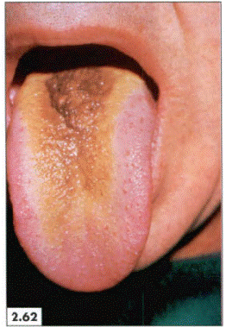
Coated tongue is ibserved during inspection
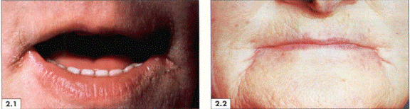
Lips are usualy bright-red in hepatitis (fig.2.1.) and spider angiomata develop (fig.2.2.)
Jaundice is usually absent or it is moderate. Objective studies reveal a mildly enlarged liver with a smooth surface and a moderately firm edge, which is slightly tender to palpation. Enlargement of the spleen is not marked.


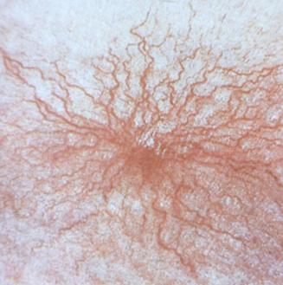
Spider angiomata
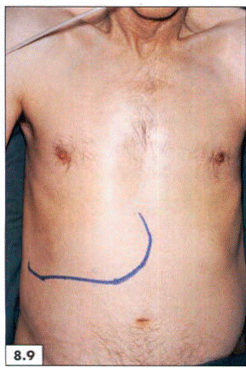
Hepatomegalia is an important sign of hepatitis
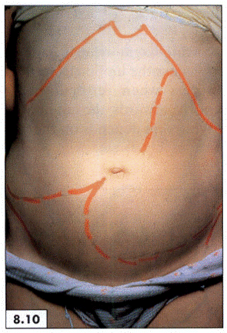
Hepatomegalia is often followed by splenomegalia

Laboratory studies. The blood bilirubin content is usually normal; in the presence of jaundice it increases to about 17-50 μmol/l; the blood globulin content is mildly increased, activity of the erzymes is either normal or only slightly changed; the prothrombin content is normal or slightly decreased; the bromsulphthalein test is slightly positive.
Chronic active hepatitis is characterized by complaints and objective symptoms: weakness, loss of weight, fever, pain in the right hypochondrium, loss of appetite, nausea,regurgitation, meteorism, skin itching, jaundice, and frequent nasal bleeding. The liver is enlarged, firm, with a sharp edge. The spleen is enlarged.
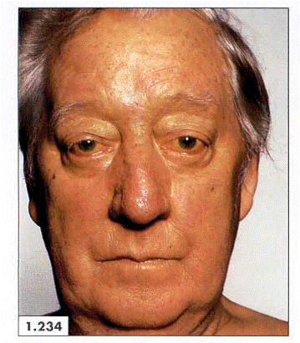
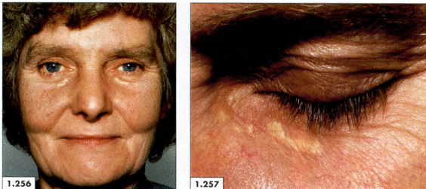
Jaundice and xanthelasma in patient with hepatitis

Laboratory tests often reveal anaemia, leucopenia, thrombocytopenia (a sign of hypersplenism), and increased ESR. Functional tests are changed considerably: they show hyperbilirubinaemia, hyperproteinaemia, hypergammaglobulinaemia, positive protein-sedimentation tests, increased activity of transaminase, aldolase, and alkaline phosphotase; decreased activity of cholinesterase. The serum iron content is significantly increased while the prothrombin index is sharply decreased; excretion of brom-sulphthajein is delayed.
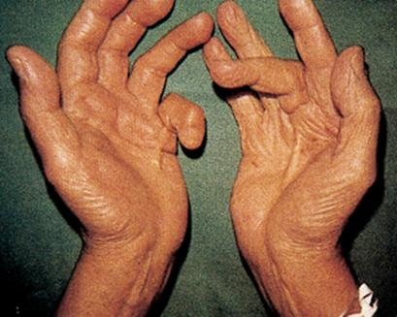
Contractura of falangies flexors is observed in active hepatitis

Puncture biopsy of the liver and (for special indications) laparoscopy establish the special histological and macroscopic changes in the liver characteristic of these forms. These techniques are also used for differentiation of chronic hepatitis from other diseases of the liver (cirrhosis, amyloidosis, etc). It should be noted that histological and histochemical studies of liver bioptates often reveal early morphological changes in the liver which precede the clinical and laboratory signs of chronic hepatitis.
Chronic cholestatic hepatitis is mainly characterized by the cholestatic syndrome: jaundice (subhepatic), severe skin itching, hyperbilirubinaemia, increased activity of alkalinephosphatase in the blood, and high cholesterol of blood. Persistent subfebrile temperature and regular increased ESR are also not infrequent.
Course. A benign hepatitis can last to 20 years; exacerbations are rare and arise only in the presence of strong provoking factors. Liver cirrhosis develops in rare cases. Complete clinical recovery i« sometimes possible, especially so if the patient is specifically treated. The morphological structure of the liver is restored in such cases.
Aggressive hepatitis is characterized by relapses, whose frequency depends on various factors. Frequent relapses accelerate progressive dystrophic, inflammatory and cicatricialchanges in the liver and stimulate development of cirrhosis. Prognosis in this form of hepatitis is bad.
The course and prognosis in cholestatic hepatitis depend on it’s aetiology and the possibility of removing the obstacle to bile outflow (in compression of the common bile duct by a tumour, cicatricial or inflammatory stenosis, etc.).
Treatment. The cause of chronic hepatitis should be removed in the first instance: complete discontinuation of taking alcohol or exposure to harmful substances, etc.
During exacerbations, the liver should be spared as much as possible, and regeneration of liver cells stimulated (bed rest, diet, parenteral use of vitamins, glucose, etc).

