HEPATOLOGY
Anatomy and physiology summary

Anatomy
The liver is the largest solid organ in the body weighing approximately 1600g in men and 1400 g in women. It lies in the right upper quadrant of the abdomen under the rib cage with its upper border between the fifth and sixth ribs and its lower border along the right costal margin where it can sometimes be palpated on inspiration in healthy subjects.

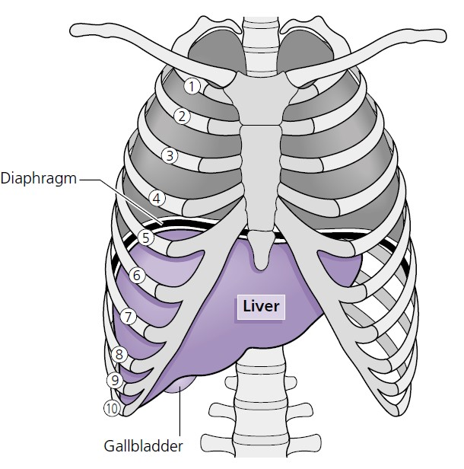

Embryological development of the liver
To understand the anatomy and vascular relationships of the adult liver it is first necessary to review its development.
Hepatic parenchyma
The primitive liver develops in the 3 - week - old embryo as an outgrowth from the distal ventral wall of the foregut. This liver bud, or hepatic diverticulum, proliferates into solid cords of endodermal cells which invade the mesenchyme of the nearby septum transversum. A series of branching and anastomosing plates spread between the umbilical and vitelline veins forming a close relationship, which eventually develops into the hepatocytes and sinusoids of the mature liver parenchyma.
Biliary system
The hepatic diverticulum divides, the large cranial part forming the hepatic parenchyma and the smaller caudal part forming an epithelial cord extending from the hepatic parenchyma to the foregut, the eventual duodenum. This solid cord becomes vacuolated forming a lumen first in the common bile duct and then in the
hepatic duct, cystic duct and gallbladder. The intrahepatic ducts begin to form from the hepatocytes in direct contact with the mesenchyme at week 9 – 10. Epithelial and mesenchymal resorption and remodelling occurs, resulting in a network of biliary tubules. Disturbance of this remodelling process is responsible for a number of disorders including congenital hepatic fibrosis, Caroli’s disease and polycystic liver disease.
Venous system
The hepatic venous system develops from four veins: two umbilical veins carrying oxygenated blood from the placenta, and two vitelline veins draining into the sinus venosus. By week 7 the definitive fetal circulation is formed:
• The right umbilical vein and the cranial portion of the left umbilical vein regress and disappear.
• The remainder of the left umbilical vein persists providing the principal source of placental blood.
• A new vessel, the ductus venosus, develops forming a bypass channel connecting the umbilical vein to the inferior vena cava.
• The upper anastomoses of the vitelline veins develop into a single portal vein with left and right branches.
• The distal vitelline veins form the superior mesenteric and splenic veins.
• At birth, blood flow ceases in the umbilical vein, the ductus venosus closes and the portal vein takes over the venous blood supply to the liver. The obliterated segment of the umbilical vein between the umbilicus and the left portal vein branch regresses to form the ligamentum teres, and the ductus venosus becomes a fibrous cord, the ligamentum venosum, running in the right lobe.

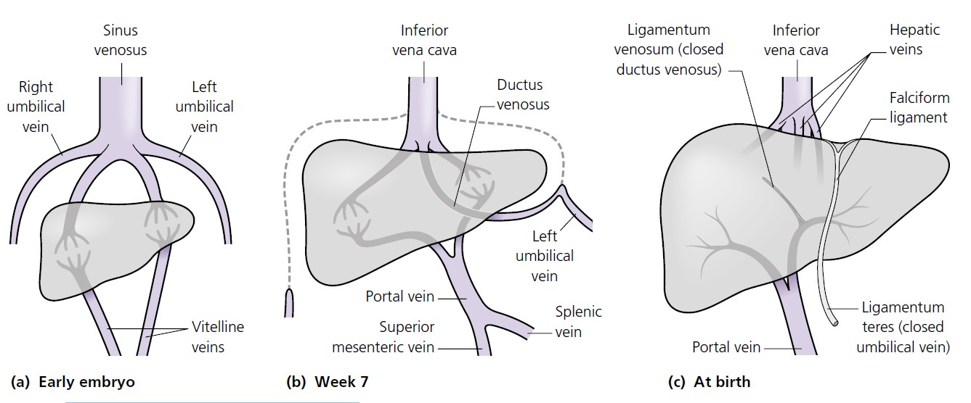
Development of the hepatic venous system.

Gross anatomy
The liver is divided into two uneven lobes, the right and left, by the falciform ligament, which is a remnant of the embryonic umbilical vein. These ‘anatomical lobes’ have no functional significance. The right lobe is larger than the left and contains the quadrate and caudate lobes.
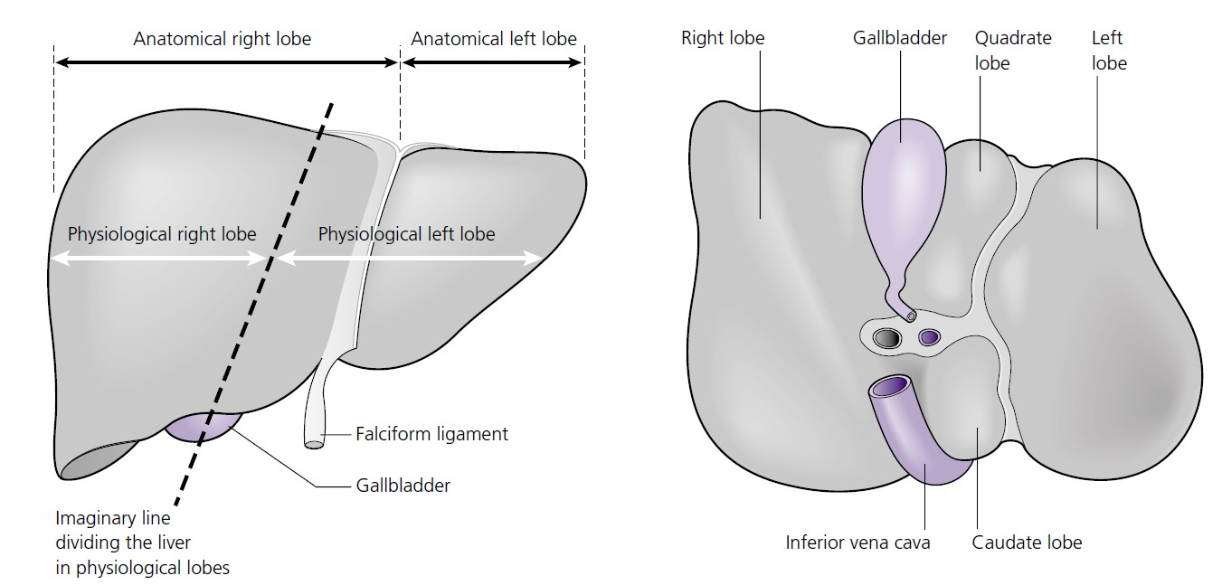
Gross anatomy of the liver
Between the quadrate and caudate lobes is the porta hepatitis or liver hilum. Here the portal vein and hepatic artery enter and the bile ducts leave the liver. In some individuals there is a downward protrusion of the anterior edge of the right lobe of the liver known as Riedel’s lobe. It may extend into the right iliac fossa and be palpable. It is considered as a normal variant. Apart from an area on its posterior surface, the bare area, the liver is covered by a fibrous capsule, Glisson’s capsule. The bare area lies in direct contact with the diaphragm and is surrounded by reflections of peritoneum. The falciform ligament attaches the liver to the
diaphragm and anterior abdominal wall. Its anterior portion, the round ligament (ligamentum teres), connects the left branch of the portal vein to the umbilicus. It contains small vestigial veins that can reopen and become varicose if intrahepatic portal venous hypertension develops.

Liver vasculature and functional anatomy
The liver receives about a quarter of the resting cardiac output via a dual blood supply:
• The portal vein provides approximately 75% of hepatic blood flow. It is formed by the union of the superior mesenteric and splenic veins and drains venous blood
from most of the digestive tract, spleen, pancreas and gallbladder.
• The hepatic artery, the second major branch of the coeliac axis, provides the remaining 25% of hepatic blood flow, but 50% of the oxygen supply. The hepatic arteries give rise to branches that supply the biliary epithelium, thus obstruction to arterial flow can result in the development of an ischaemic cholangitis.

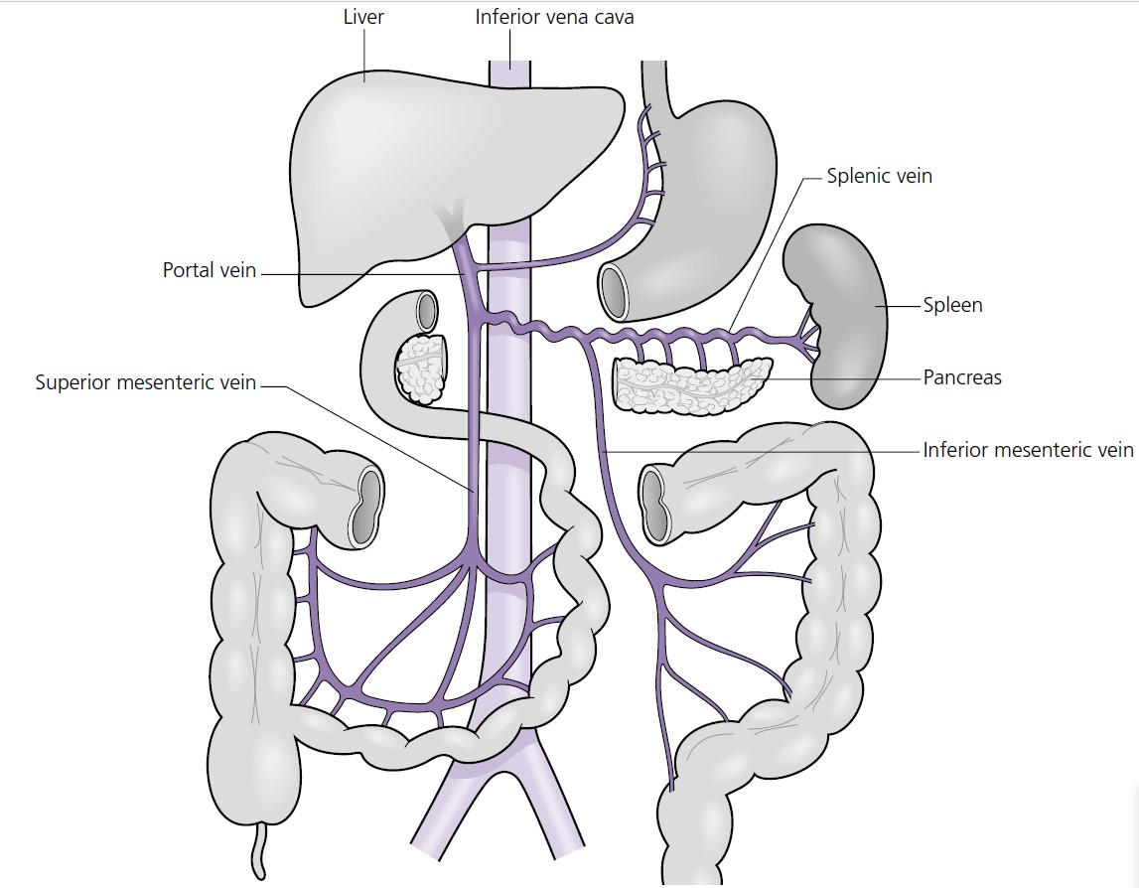

Anatomy of the portal vein

The distribution of the hepatic blood supply and biliary drainage divides the liver functionally into two roughly equal ‘ physiological lobes ’ . The line of demarcation between right and left vascular inflow passes along a plane joining the tip of the gallbladder to the groove of the inferior vena cava. The understanding of this vascular anatomy and the recognition of true right and left lobes is of major importance in radiologically staging hepatic tumours and in surgical resection of the liver.
The liver is drained by three major veins, the right, middle and left hepatic veins. As they emerge from the posterior surface of the liver the left and middle veins usually join, forming a common trunk that drains alongside the right hepatic vein into the inferior vena cava just before it passes through the diaphragm. In addition to the main hepatic veins, small inferior veins drain the posterior segment of the right lobe and the caudate lobe directly into the vena cava. This arrangement protects the caudate lobe from injury and allows it to hypertrophy if the main hepatic veins are occluded (Budd – Chiari syndrome).
Biliary drainage
Within the hepatic parenchyma bile canaliculi form an anastomosing network between the hepatocytes. They join near the portal tracts and form progressively larger ducts, eventually creating right and left hepatic ducts which leave the right and left liver lobes, respectively. The hepatic ducts meet at the porta hepatis and unite, forming the common hepatic duct. The gallbladder lies under the
right lobe of the liver where it stores and concentrates bile. It is drained by the cystic duct, which joins the common hepatic duct to form the common bile duct.
The common bile duct runs behind the first part of the duodenum in the groove on the back of the head of the pancreas and enters the second part of the duodenum,
usually joining the main pancreatic duct to form a common channel, the ampulla of Vater.
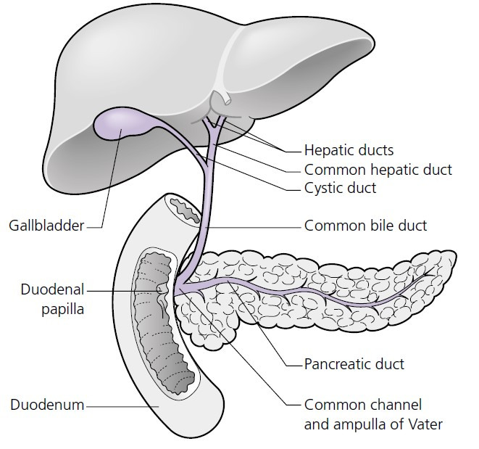
The extrahepatic biliary tree

The lower end of the common bile duct contains the muscular sphincter of Oddi which prevents bile entering the duodenum in the fasting state. In about 30% of individuals, the bile duct and pancreatic duct open separately into the duodenum.

Intrahepatic organisation
The hepatic artery and portal vein enter the porta hepatis within a sheath of connective tissue, the gastroduodenal ligament, which also contains bile duct branches as they leave the liver. The vessels run parallel and branch in all directions eventually emptying into the hepatic sinusoids. Blood passes from the portal tract via the hepatic sinusoids to the terminal vein (central vein). The hepatic veins run in the opposite direction to the portal tract with terminal hepatic venules collecting blood from the sinusoids and forming larger channels leading to the main hepatic veins. Two models have been proposed for the functional unit of the liver:

1 The classic lobule is a hexagonal structure organised around a central venule, a tributary of the hepatic vein, with the portal tracts forming the corners of the hexagon. This model is convenient for describing centrilobular or erilobular structural alterations occurring around the hepatic venule or portal tracts, respectively, but it is not an isolated functional unit.
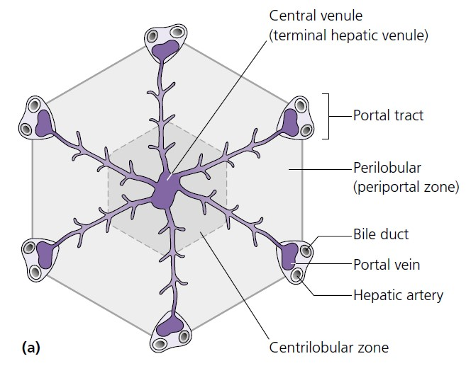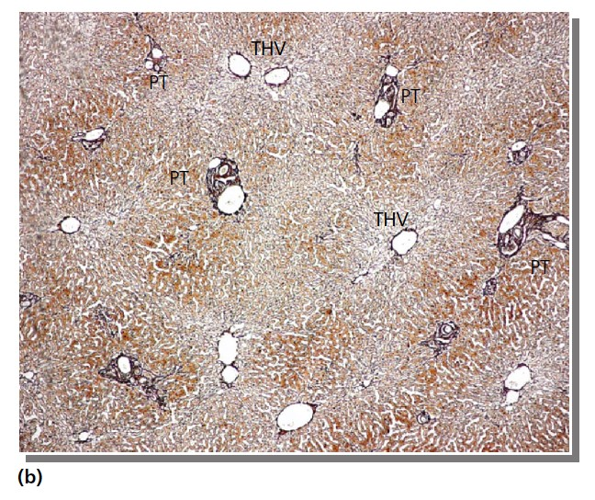

Proposed models for the functional unit of the liver. (a) Classic lobule. (b) Normal liver showing the spatial relationship between the portal tracts (PT) and terminal hepatic venules (THV). (Reticulin stain.)

2 The liver acinus more accurately describes the functional unit of the liver and describes the hepatic parenchyma in zones:
• Hepatocytes in zone 1 are closest to the portal triad; they receive the richest supply of oxygen and nutrients but are more likely to be damaged by drugs and toxins as they are exposed to higher concentrations of these.
• Zone 3 hepatocytes are near the central vein and have a relatively poor oxygen supply and are therefore particularly susceptible to hypoxic damage.
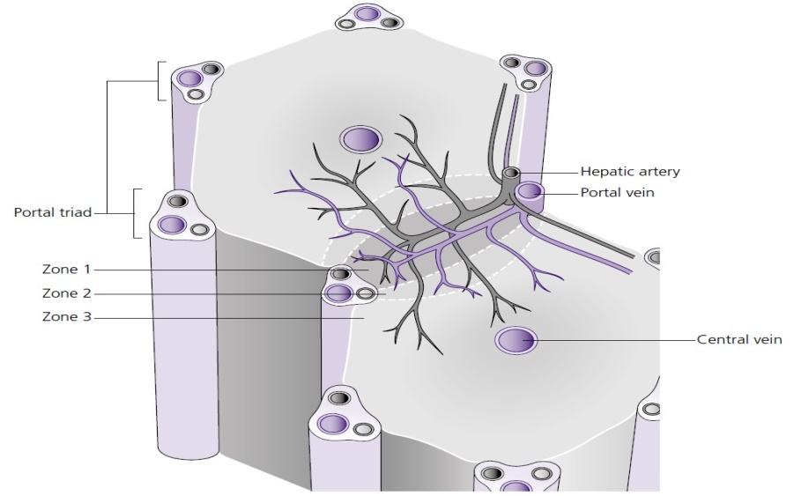
Functional liver acinus.

Tissues of the liver
Hepatocytes
Eighty to 85% of the liver volume is made up of hepatocytes – polyhedral - shaped, polarised epithelial cells. The cells are arranged in plates with the basolateral surface projecting into the perisinusoidal space of Disse where they are in direct contact with cell - free blood.
Cholangiocytes
The bile ducts are composed of epithelial cells, called cholangiocytes. The cells lining the small interlobular ducts are cuboidal, whereas those of the larger bile ducts are columnar, mucus - secreting cells.
Cells of the sinusoid
The vascular sinusoids are lined by endothelial cells that contain numerous fenestrae allowing free passage of solutes into the space of Disse that lies between the sinusoidal endothelial cells and the hepatocytes.
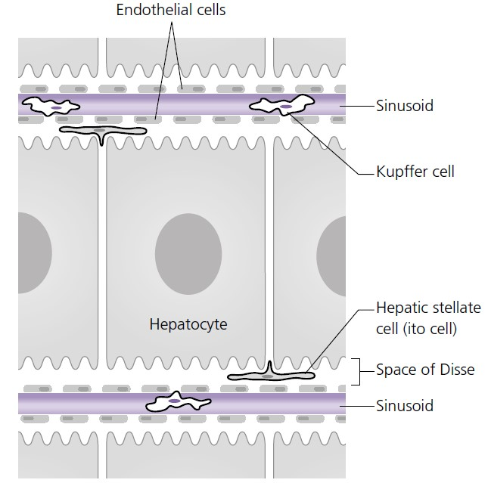
Anatomy of the hepatic sinusoid.

This space of Disse contains perisinusoidal cells, the hepatic stellate cells also known as Ito cells. These are multifunctional cells involved in fat and vitamin storage and with the potential to transform into fibroblasts, which are a major source of extracellular matrix in the normal and diseased liver. Kupffer cells float freely in the lumen of the sinusoids. They are members of the mononuclear phagocytic system and are responsible for the clearance of particles, injured red cells and toxins. Liver – associated lymphocytes can be recruited from the peripheral blood to the liver sinusoids where they mature and acquire natural and lymphokine - activated cell activity.

Lymphatics
Hepatic lymph is formed by drainage of the perisinusoidal space of Disse into lymphatic plexuses of the portal tract. The lymphatic plexuses progressively enlarge as they follow the portal vessels to the portal hepatitis, and the majority drain into hepatic lymph nodes at the liver hilum. Other drainage routes occur via the falciform ligament and epigastric vessels to the parasternal nodes, from the liver surface to the left gastric nodes and from the bare area to the posterior mediastinal nodes.
Nerve supply
Nerve plexuses around the hepatic artery and portal vein provide parasympathetic fi bres from the vagus nerve and sympathetic fibres from the coeliac ganglia.

Physiology
Bile formation and excretion
Bile secretion is an important exocrine function of the liver. Bile is a mixture of water, electrolytes, bile pigments (largely bilirubin), bile acids, cholesterol, phospholipids, albumin and immunoglobulins. This composition allows it to have a broad range of physiological functions including lipid digestion and absorption, immunological defence, excretion of endogenous compounds and removal of xenobiotics.
Formation of bilirubin
The body produces approximately 250– 400 mg of bilirubin daily, primarily from the breakdown of haemoglobin:
• Haem is enzymatically degraded releasing iron, carbon monoxide and biliverdin (green), which is subsequently reduced to bilirubin (yellow) by the enzyme biliverdin reductase.
• This unconjugated bilirubin is water insoluble and therefore circulates in plasma tightly bound to albumin.
• Conjugation of bilirubin with glucoronic acid occurs in hepatocytes and confers water solubility, allowing efficient excretion in the bile:
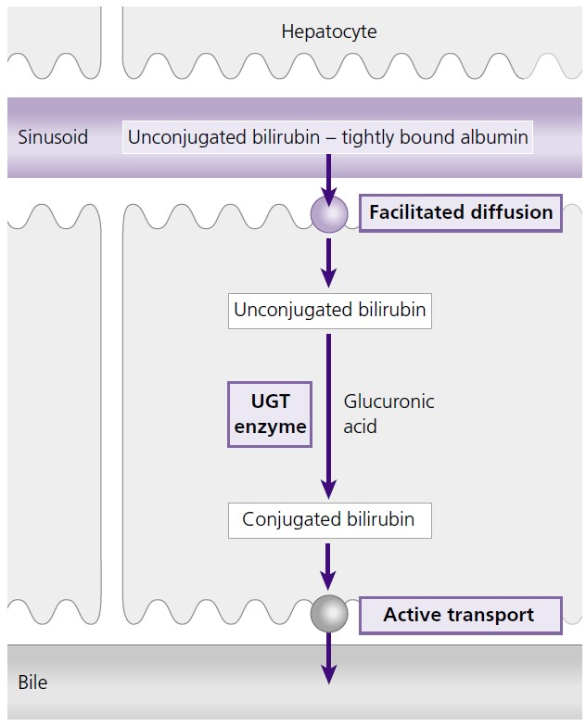
• Following conjugation, the major bilirubin pigment is bilirubin diglucoronide; bilirubin monoglucoronide and unconjugated bilirubin account for less than 20% of the pigments.
• Conjugated bilirubin is transported from the hepatocyte to the biliary canaliculus by an adenosine triphosphate (ATP) dependent export pump.
A number of inherited conditions are caused by defects in the process of bilirubin conjugation and excretion from the liver: 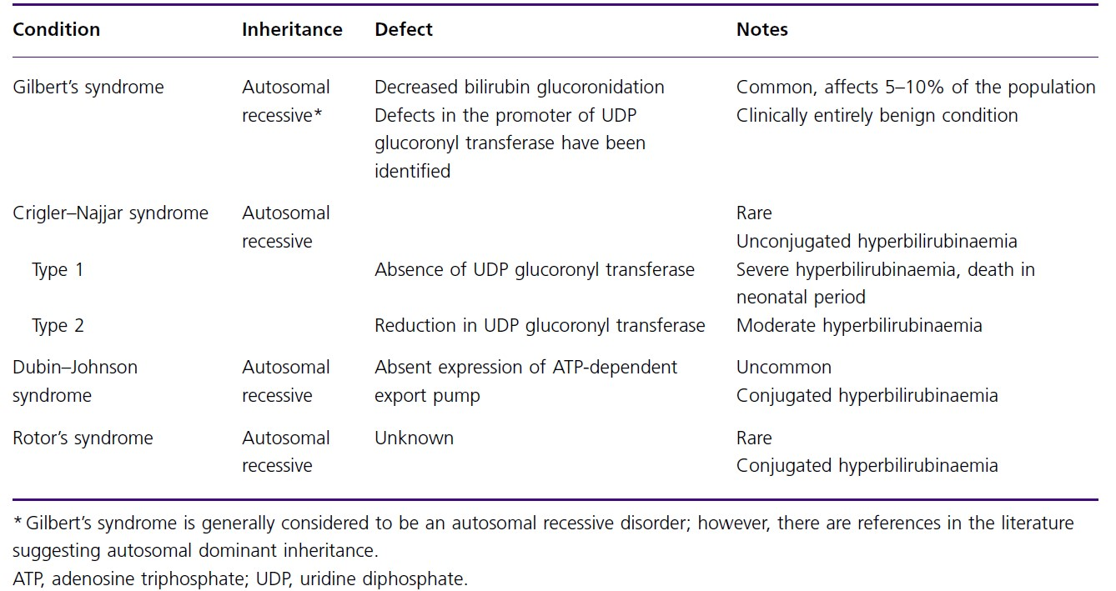

Enterohepatic circulation
Conjugated bilirubin is water soluble and therefore there is little reabsorption in the small intestine.
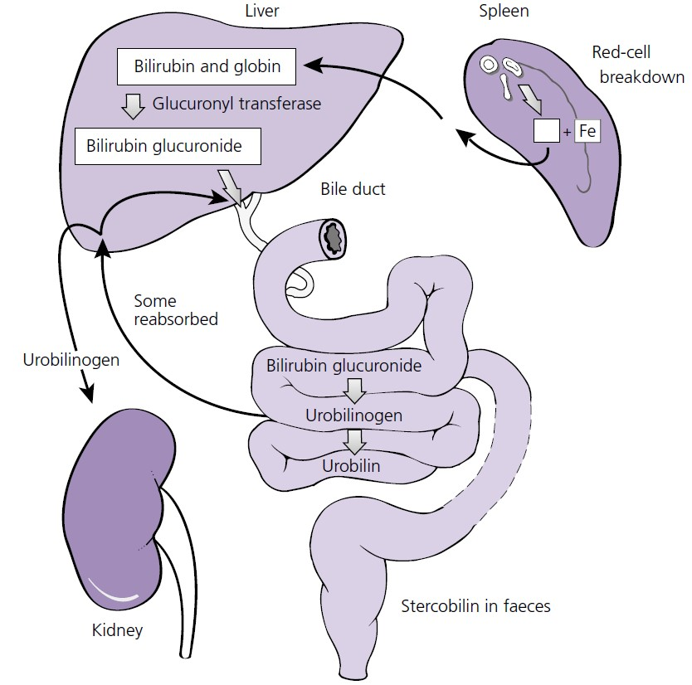
Metabolism of bilirubin.
In the colon, bacterial glucoronidases hydrolyse conjugated bilirubin, forming urobilinogen, a non - polar substance that is reabsorbed in the intestine. This is re - excreted in the bile (major fraction) or urine (minor fraction). Although urobilinogen is colourless, its oxidised product urobilin contributes to the colour of stool and urine.
Urobilinogen is further converted to stercobilin in the colon.

Clinical implications of bilirubin metabolism: 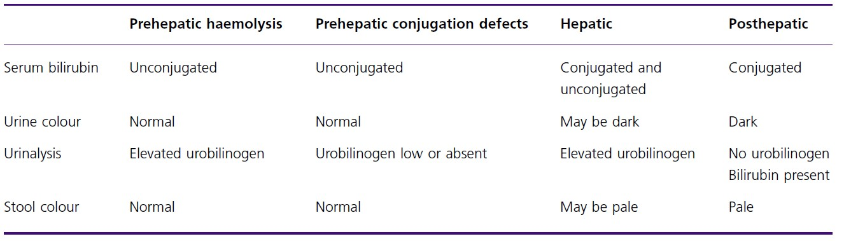 • Prehepatic jaundice causes an increase in unconjugated bilirubin; this is bound to albumin and is not detected in the urine, which remains a normal colour. The stool colour is normal.
- In haemolysis there is increased delivery of bilirubin to the gut resulting in increased production of urobilinogen.
- In conjugating enzyme defects there is reduced formation of urobilinogen.
• In obstructive jaundice there is disruption to the enterohepatic circulation, urobilinogen and urobilin are absent from the urine, and stercobilin is absent from the stools, which become pale. The urine becomes dark because there is excess conjugated bilirubin in the blood which is water soluble and therefore passes through the renal glomerular filter into the urine.
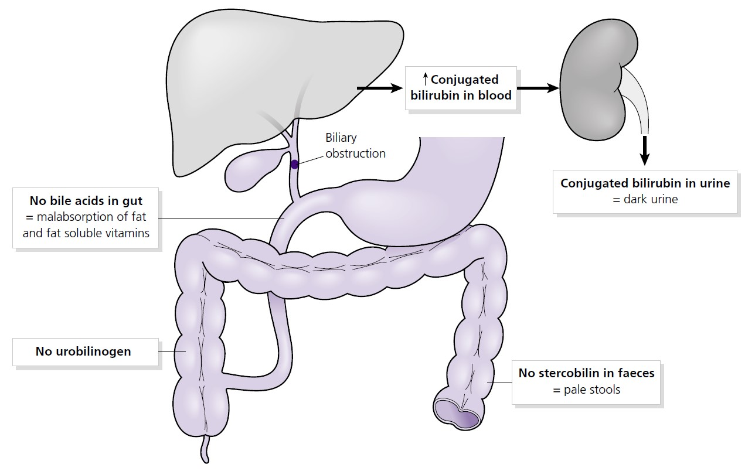
• In hepatocellular damage, there is impairment of conjugation within the hepatocytes and transport of conjugated bilirubin from the hepatocytes to the bile duct resulting in raised plasma concentration of unconjugated and conjugated bilirubin. Urobilinogen re - excretion by the liver is also affected, resulting in increased excretion in the urine.

Bile acids
Bile acids are synthesised in the liver from cholesterol. They are conjugated in the liver with amino acids (glycine or taurine) to form bile salts, which are excreted in bile. In the intestine bile salts are reabsorbed in the terminal ileum. The small fraction that enters the colon is converted to secondary bile salts by the action of colonic bacteria, which then enters the enterohepatic circulation.
There are a number of functions of bile acids/salts:
• Contribution to secretion of cholesterol and phospholipids from the liver.
• Major solute of bile and contributes to bile flow.
• Allows excretion of lipid- soluble substances by forming micelles.
• Absorption and digestion of lipids, including lipid - soluble vitamins.
• Signalling properties in the hepatocyte and biliary epithelium (e.g. regulate expression of genes responsible for bile synthesis and metabolism).
Clinical implications of bile acids
• In biliary obstruction a reduction in bile salt excretion may cause deficiencies in the absorption of fat – soluble vitamins (A, D, E and K). In the context of liver disease, this may result in prolonged coagulation because of the resulting low levels of vitamin K.
• Disease or resection of the terminal ileum interrupts the normal enterohepatic circulation of bile salts. The increased delivery of bile salts to the colon may cause
diarrhoea and result in electrolyte and water loss in the faeces.
Gallbladder function
The principle functions of the gallbladder are the storage and concentration of bile. In response to neurological reflexes and the gut hormone cholecystokinin (CCK) it contracts to release bile in the duodenum. Although it is not essential for bile secretion, it concentrates bile by up to 10 - fold and patients who have had their gallbladder removed may develop upper gastrointestinal symptoms such as oesophagitis or gastritis related to the continuous flow of bile into the gut.

Central metabolic functions of the liver
The liver is a central hub for the metabolism of carbohydrates, protein and lipids. Within the sinusoid there are zones where different metabolic processes are
concentrated.

Glucose metabolism
The liver has a pivotal role in glucose homeostasis. Following a meal approximately 25% of the glucose content is metabolised in the liver – stored as glycogen, oxidised or converted to fat. The liver maintains plasma blood glucose levels by two distinct pathways, gluconeogenesis (converts carbon - containing compounds such as amino acids into glucose) and glycogenolysis (conversion
of glycogen into glucose).
• The homeostasis between glucose storage and glucose production is relative to the concentrations of the hormones insulin (produced in pancreatic β cells) and
glucagon (produced in pancreatic alpha cells).
• A raised insulin : glucagon ratio inhibits gluconeogenesis and promotes glycogen synthesis.
• A reduced insulin : glucagon ratio promotes gluconeogenesis and inhibits glycogen synthesis.

Protein and amino acid metabolism
The liver has diverse functions pertaining to protein metabolism, including:
• The synthesis and degradation of amino acids and proteins including albumin, globulin and fibrinogen.
• The production of ammonia from the deamination of amino acids and subsequent conversion to urea (via the intermediates ornithine, citruline and arginine) by the urea cycle, which occurs exclusively in the liver.
• The production of glucose from the main ‘ gluconeogenic ’ amino acids alanine and glutamine.
• The production of fatty acids from ‘ ketogenic’ amino acids, e.g. leucine and lysine.
• The formation of glutathione (important antioxidant role) and creatine (an important energy source in skeletal muscle which spontaneously breaks down to creatinine), which is dependent upon amino acid metabolism within the liver.

Lipid metabolism
Cholesterol degradation and excretion is dependent on the liver. Due to their insolubility, the transport of cholesterol and triglycerides is reliant on lipoproteins:
• Chylomicrons, very low density lipoproteins (VLDLs), low density lipoproteins (LDLs) and high density lipoproteins (HDLs) are all part of the apolipoprotein family.
• With increasing density, there is reducing size, reduced cholesterol content and increased protein content of the particles.
• Lipids are transported from the intestine to the liver in chylomicrons.
• The liver exports fatty acids as VLDLs, which releases free fatty acids by the action of peripheral lipoprotein lipases.
• LDLs are taken up by target tissues by endocytosis or by LDL - receptor - mediated uptake in the liver.
• HDLs transport cholesterol back to the liver for elimination.
• Cholesterol within the liver is excreted as bile salts.

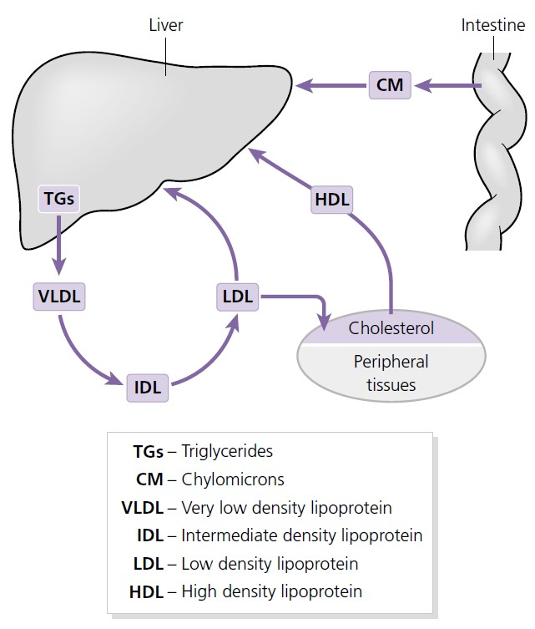
Lipid transport and the liver.

Clinical implications of disordered metabolism in liver disease
• Glycogen storage diseases are inherited disorders caused by deficiency of enzymes that catalyse the conversion of glycogen and glucose. In the hepatic forms this can result in hypoglycaemia, hepatomegaly (due to excess glycogen in the liver) and growth retardation.
• In severe acute liver failure, hypoglycaemia occurs because of the inability of the liver to maintain plasma glucose by either gluconeogenesis or glycogenolysis.
• In cirrhosis there may be a combination of reduced glycogen reserves (less glycogenolysis), which is compensated for by increased gluconeogenesis.
• Insulin resistance, altered carbohydrate and lipid metabolism (resulting in increased free fatty acid efflux into the liver) and inflammatory cytokines contribute to the condition of non - alcoholic fatty liver disease (NAFLD).
• Reduced muscle mass in chronic liver disease is a reflection of reduced nutritional intake but also increased catabolism (may reflect increased proteolysis for the provision of gluconeogenic amino acids).
• The inability of the liver to adequately metabolise ammonia (because of increased portosystemic shunting and reduced elimination in the urea cycle) may have an important aetiological role in the development of hepatic encephalopathy.

Drug metabolism
The liver plays a major role in drug metabolism and elimination. Drugs are taken up by the liver and then processed by a number of enzymatic reactions:
1 Phase 1 metabolism alters the structural integrity of the drug by enzymes, including the cytochrome P450 system. The resultant metabolite is not necessarily detoxified and may in fact be more active (e.g. the metabolite N - acetyl - p - benzoquionimine (NAPQI) produced by phase I metabolism of paracetamol is hepatotoxic). The efficacy of this system is determined by genetic factors
and also induction by other drugs.
2 Phase 2 metabolism results in conjugation of the metabolite, which can detoxify and increase solubility for excretion. Liver disease can affect drug metabolism in a number of ways. Firstly, portosystemic shunting will reduce metabolism of drugs within the liver and, secondly, reduced albumin synthesis will alter the ratio of unbound : bound drug in the plasma.

Immune function
The vascular supply through the liver and the arrival of potentially pathogenic substances, via the portal vein from the gut, makes the liver an important immunological site.
The liver has diverse immune functions:
• Kupffer cells are resident macrophages located in the hepatic sinusoids. They have important roles in phagocytosis, cytokine and chemokine release and activation of other cells including the hepatic stellate cell.
• In addition to the trafficking of activated lymphocytes from the circulation into the liver there is also a specific intrahepatic population of lymphocytes, natural killer cells (part of the innate immune system) and dendritic cells (which present antigen to T cells).
• Immune tolerance may have particular relevance for the liver in view of the high antigenic load it receives from the gut. There is a balance of protecting against excessive immune activation (e.g. autoimmunity) versus allowing the persistence of pathogens (chronic viral hepatitis).
• Secretory IgA in the bile contributes to hepatobiliary and gastrointestinal mucosal immunity. Raised serum levels of IgA are found in alcoholic liver disease; the exact reason is uncertain but there is some evidence that alcohol can disrupt the gastrointestinal epithelial barrier resulting in greater antigen translocation across the gut.

Pathophysiological processes affecting the liver
Acute inflammation
The causes of acute hepatitis are broad. Damage may occur by hepatocellular necrosis or apoptosis (programmed cell death).
Causes of acute inflammation:
• Infection:
- hepatitis A, B, C, D and E
- Epstein – Barr virus, cytomegalovirus, herpes simplex virus
• Drugs: paracetamol, ecstasy, herbal remedies
• Vascular:
- ischaemia
- Budd – Chiari syndrome (obstruction of the large hepatic veins)
• Metabolic: Wilson ’ s disease
• Malignancy: malignant infiltration of the liver
• Pregnancy: acute fatty liver of pregnancy
• Miscellaneous:
- autoimmune hepatitis
- sepsis
- Amanita mushroom poisoning
- heat stroke
The liver injury can result in asymptomatic transaminitis (deranged liver function tests but no clinical signs or symptoms), anicteric hepatitis (no jaundice but symptoms such as fever, vomiting, right upper quadrant discomfort, etc.), icteric hepatitis (jaundice but no encephalopathy) or fulminant liver failure (coagulopathy and hepatic encephalopathy). The liver has a remarkable capacity for regeneration and the balance of this regeneration versus injury will determine the outcome:
• Acute hepatitis with complete resolution.
• Fulminant liver failure.
• Chronic liver injury leading to fibrosis.

Acute liver failure
The term acute liver failure implies the presence of encephalopathy in the context of an acute liver injury.
The following classification is often used:
• Hyperacute liver failure: encephalopathy within 7 days of jaundice.
• Acute liver failure: encephalopathy between 8 and 28 days after the onset of jaundice.
• Subacute liver failure: encephalopathy between 5 and 12 weeks after the onset of jaundice.
Inadequate liver function results in reduced hepatic metabolism of ammonia and contributes to the development of encephalopathy. The resulting excessive ammonia is metabolised in the brain causing accumulation of glutamine in astrocytes, raised cellular osmotic pressure and cerebral oedema. Oedema is further
accentuated by an increase in cerebral blood flow due to disruption of the normal autoregulatory mechanisms. If the intracranial pressure becomes elevated above a critical threshold cerebral perfusion may be compromised and brainstem herniation can occur.
In addition to encephalopathy other clinical manifestations include renal dysfunction, hyperdynamic circulation (increased cardiac output and reduced systemic vascular resistance), hyperventilation, prolonged coagulation, sepsis (including fungal infections) and hypoglycaemia.

Chronic liver injury, fibrosis and cirrhosis
Chronic liver injury can result from a spectrum of insults and frequently leads to fibrosis, an innate wound healing response of the body: 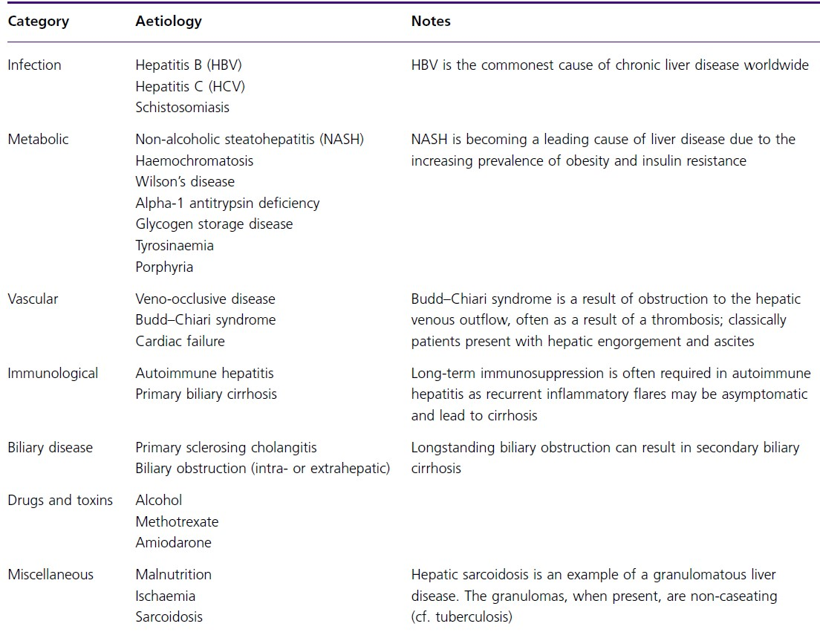
Fibrosis usually takes several years to develop but can occasionally develop rapidly over months (e.g childhood biliary atresia, certain drug - induced liver diseases and the post liver transplantation setting). Liver fibrosis is characterised
by the deposition of extracellular matrix (scar tissue) consisting of collagens, hyaluronic acid, proteoglycans and matrix glycoproteins. The hepatic stellate cell, residing in the space of Disse within the sinusoids, plays a central role in secreting collagen scar tissue. Progressive injury eventually leads to the formation of fibrous tissue bands separating nodules of regenerative hepatocytes, when it is known as cirrhosis. Cirrhosis may be defined as micronodular (small nodules less than 3 mm) or macronodular.
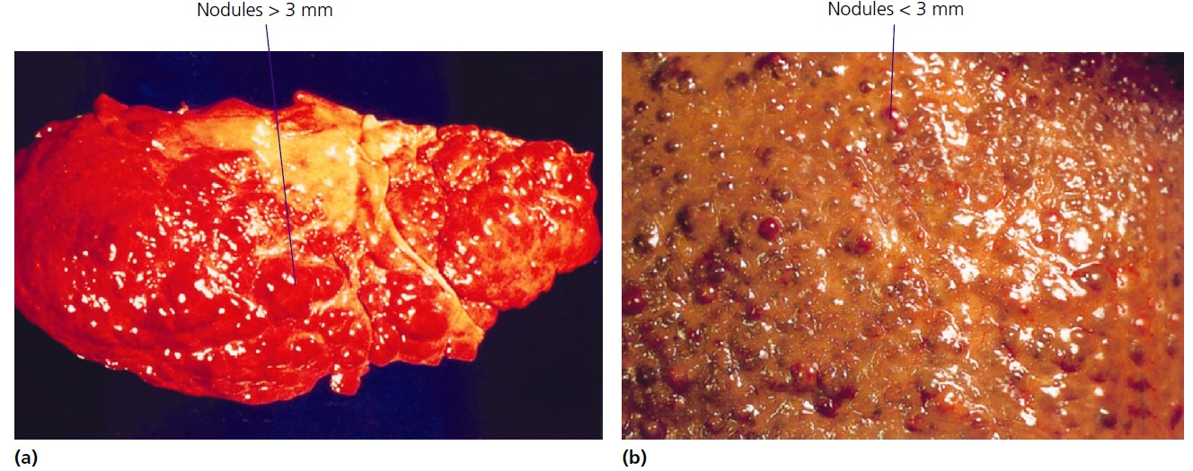
Macroscopic photographs of a liver showing cirrhosis: (a) Macronodular cirrhosis. (b) Micronodular cirrhosis.

The development of cirrhosis alters haemodynamics within and outside the liver. Extracellular matrix deposition within the sinusoids causes a loss of the normal fenestration (analogous to changing from a porous pipe to a lead pipe) and subsequent reduced filtration and hypoxia. Furthermore, the release of angiogenic factors stimulates new blood vessel formation (neoangiogenesis) within the fibrous tissue. The resulting intrahepatic shunting of blood contributes to the reduction in hepatic function that occurs in advanced fibrosis and cirrhosis.
The vascular resistance in the liver increases due to a combination of structural alterations (e.g. scar tissue and nodules) and dynamic alterations (e.g. contraction of then hepatic stellate cell) in the liver parenchyma. The rise in intrahepatic vascular resistance contributes to the elevation in portal venous pressure that frequently complicates cirrhosis.

Regeneration
The human liver is the only organ able to regenerate lost tissue. A whole liver can regenerate from as little as 25% of its normal size. The mechanisms are not entirely clear but probably involve hepatocytes entering cell cycle in response to signals including growth factors and cytokines. There is also evidence for bipotential stem cells (oval cells) that can differentiate into either hepatocytes or cholangiocytes. Once a liver has become chronically damaged and has developed extensive fibrosis its ability to regenerate becomes impaired, an important fact in selecting patients for surgical resection.

Neoplasia
Neoplasia is the abnormal proliferation of cells. It results when a cell becomes genetically altered so that it evades the normal controls on growth and proliferation. A neoplasm may be benign (e.g. adenoma) or malignant, when it is frequently called a cancer. Malignant neoplasms may invade and destroy surrounding tissues, they can spread (metastasise) and may kill the host. The liver is a frequent site of spread from other neoplasms, particularly those of the gastrointestinal tract and pancreas, which are drained by the portal venous system.
Hepatic metastases may be solitary or multiple. Neoplasms relevant to the hepatobiliary system are demonstrated below: 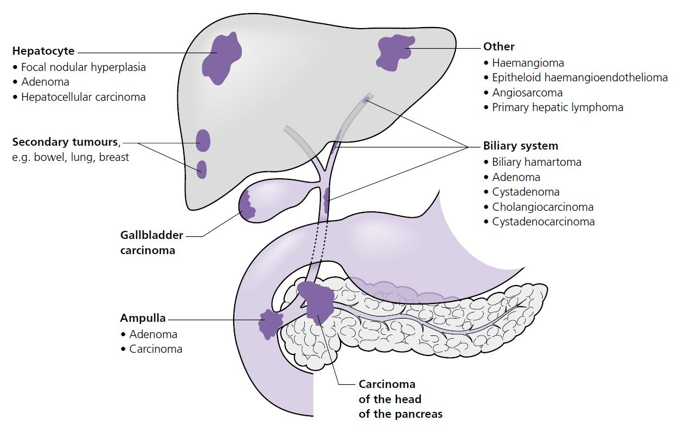
Neoplasms affecting the hepatobiliary system.

Multiple mechanisms are responsible for the genetic changes that occur in neoplasia. Eighty per cent of hepatocellular carcinomas (HCCs) occur on a background of cirrhosis, probably because the repeated cycles of inflammation,
oxidative damage and repair result in genetic damage that predisposes to malignant change. Hepatitis B virus causes HCC by inducing cirrhosis but can also cause
HCC in non - cirrhotic livers, which may be secondary to its ability to integrate into host cellular DNA.
Risk factors for developing the commonest malignant neoplasms, HCC and cholangiocarcinoma, are shown below.
The main aetiological factors for hepatobiliary carcinomas:
1. Hepatocellular carcinoma:
• Cirrhosis (all causes but especially HBV, HCV, alcohol and haemochromatosis)
• Hepatitis B virus (even in the absence of cirrhosis)
• Aflatoxins from Aspergillus flavus and A. parasiticus

2. Cholangiocarcinoma:
• Primary sclerosing cholangitis
• Chronic gallstones
• Liver fluke (Clonorchis sinensis )
The site of the neoplasm determines the characteristic of the disease presentation. For example, lesions in the biliary system frequently cause obstruction and present with jaundice, whereas lesions in the liver parenchyma rarely cause jaundice until late stages and are only picked up when disease is advanced unless they are detected incidentally or as a result of screening. Consequently, the prognosis of hepatobiliary malignant neoplasms is frequently poor.
Infection
Infection occurs when a microorganism enters a host and replicates there. Disease results when the microorganism
Main aetiological factors for hepatobiliary carcinomas
• Cirrhosis (all causes but especially HBV, HCV, alcohol and haemochromatosis)
• Hepatitis B virus (even in the absence of cirrhosis)
• Aflatoxins from Aspergillus flavus and A. parasiticus
Cholangiocarcinoma
• Primary sclerosing cholangitis
• Chronic gallstones
• Liver fluke ( Clonorchis sinensis ) causes damage to the host during the process of infection.
The liver is frequently involved in infection, either as the primary target organ or as part of a generalised multiorgan process. The portal venous circulation and the biliary tract provide potential routes for infectious agents to access the liver from the gastrointestinal tract. In addition, the rich vascular supply to the liver results in it being susceptible to infection as a consequence of systemic infections.
Many different classes of microorganism can result in hepatic infection:
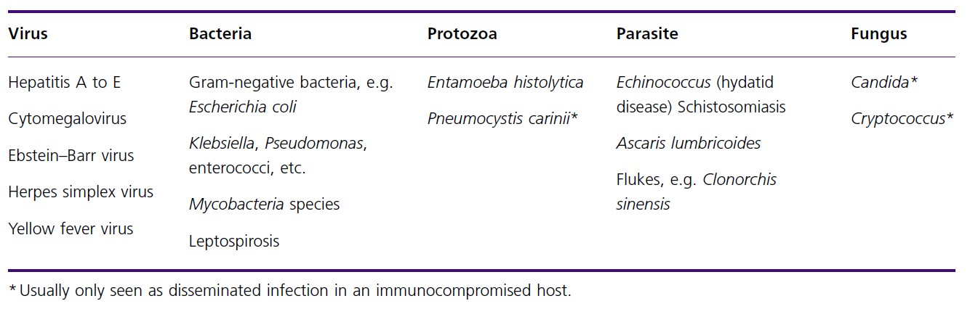

Clinical impact of infection
The clinical impact of hepatic infection is determined by a number of factors including the site of infection, the mechanism by which the organism causes damage and the extent of the host’s response to the invading organism.
Site of infection
The clinical features of hepatic infection are determined by the site of infection.
Liver parenchyma
• Hepatitis: Hepatitis is the term given for inflammation of the liver parenchyma; infection, in particular viral infection, is an important cause. Viruses may cause hepatitis as a primary manifestation of infection (e.g. hepatitis A to E) or as part of a more generalised systemic infection (e.g. cytomegalovirus, Ebstein – Barr virus, herpes simplex virus). Infectious hepatitis results in a spectrum of clinical syndromes ranging from subclinical infection, to clinical infection with or without jaundice, to acute liver failure with possible death (rare).
• Abscess: Abscesses in the liver are most frequently caused by bacteria, although amoebic abscesses may be seen in travellers to endemic areas and fungal abscesses can occur in the immunocompromised. Typical symptoms are malaise, anorexia, fever and right upper quadrant discomfort.
• Tuberculosis: Liver involvement in tuberculosis (TB) is common, histological abnormalities being seen in up to 75% of patients with pulmonary TB as a consequence of haematogenous spread from the primary source. Diffuse parenchymal hepatic TB is the most common form, characterised by small ( < 1 mm) granulomas throughout the liver parenchyma. Less commonly, focal hepatic TB occurs with a tuberculous liver abscess or tuberculoma. These lesions are usually larger ( > 2 mm) and may be solitary or multiple.

Biliary system
• Cholangitis: Cholangitis is the result of infection within the biliary system. It frequently occurs when there is obstruction to biliary drainage, for example by impaction of a gallstone in the bile duct, with ascending infection behind the obstruction. Cholangitis may also occur as a complication of surgery or endoscopic instrumentation of the biliary tract (e.g. endoscopic retrograde cholangiopancreatography (ERCP)). The invading microorganisms arise from the gastrointestinal tract (e.g. Escherichia coli ). Spread of the microorganisms into the
liver parenchyma may occur with development of hepatic abscesses. Patients with ascending cholangitis typically present with fever, jaundice and right upper quadrant pain (Charcot’s triad).
• Gallbladder empyema: Bacterial contamination of the gallbladder may result in production of a purulent inflammatory exudate resulting in a gallbladder empyema. This usually results from obstruction of the cystic duct, typically by gallstones. The patient is unwell and requires antibiotics and urgent drainage or removal of the gallbladder.
• Parasitic infection: Some parasites can infect the biliary system in humans.
- Fasciola hepatica is a sheep fluke found in parts of Europe including England. Flukes hatch in the small intestine, penetrate the intestinal wall, cross the
peritoneal cavity and enter the hepatic parenchyma, eventually reaching the biliary tree. Here mature worms produce eggs in the bile duct, which enter the small intestine and are passed from the body in faeces. Infection may be asymptomatic or may mimic ascending cholangitis.
- Tapeworms of the Echinococcus genus can infect the liver. Humans become infected by ingesting eggs that hatch in the intestine and migrate to the liver and other organs. Large complex cysts (hydatid cysts) can form in the liver which may be asymptomatic or cause symptoms related to pressure.
- Clonorchis sinensis is a liver fluke most commonly seen in Asia. The adult flukes live in the bilenducts and release eggs that can result in severe inflammation and fibrosis. Infestation with this parasite has been linked to the development of cholangiocarcinoma.
Blood vessels
Schistosomiasis (bilharzia). Schistosoma mansoni and S. japonica cause liver disease. Cercariae from infected water enter humans by penetrating unbroken skin. They migrate through the venous system to the liver and mesenteric veins where the adult worms mature and produce eggs. Eggs retained in the mesenteric vessels produce intense inflammation and fibrosis. Hepatic schistosomiasis results in fibrosis around the portal veins and a granulomatous inflammation within the hepatic parenchyma. Patients are not cirrhotic but the severe periportal fibrosis leads to portal hypertension and subsequent development of splenomegaly, ascites and varices.
Mechanisms of disease
Disease may result from direct damage caused by the invading microorganism itself or indirectly via the host ’ s response to the microorganism, or a combination of the two.
Direct damage
Only a few organisms cause hepatic disease by directly damaging the host. Some of the viruses that cause haemorrhagic fevers (e.g. yellow fever or Rift Valley fever) can cause direct hepatocyte necrosis. As a part of a multisystem illness these viruses diffusely infect hepatocytes which are destroyed by the replicating virus, resulting in death in up to 50% of cases. Hepatitis viruses may in
some circumstances cause disease by a direct cytopathic effect but the main mechanism of disease is by indirect damage (see below).
Indirect damage
• Inflammation: The presence of microorganisms in tissues frequently elicits an inflammatory reaction as part of the host response to attempt to destroy and eradicate the invading organism. Often this inflammation itself leads to damage that produces disease. An example of this is the inflammatory response to schistosomal eggs mentioned above. The presence of the eggs in the portal vessels induces a granulomatous inflammatory reaction which eventually results in healing by fibrosis. Disease is then caused by the fibrotic narrowing of the portal
vessels, resulting in portal hypertension.
• Immune response: Hepatitis viruses classically cause disease by inducing an immune response. The extent and severity of the disease is related to the strength of the immune response to the virus and varies considerably between individuals.
This is best illustrated by hepatitis B virus (HBV) infection. Infection acquired as a neonate, when the immune system is immature, almost invariably results in chronic carriage of the virus. Individuals have high levels of viraemia but remain well with normal liver blood tests and normal liver histology. Individuals who acquire HBV infection as an adult, however, may have a more developed immunological response and develop symptomatic hepatitis. Liver blood tests may be abnormal and biopsy reveals hepatocyte necrosis with lymphocyte infiltration of the liver parenchyma. In the most extreme example of symptomatic hepatitis B infection,nthe immune response is so intense that total hepatocyte necrosis occurs and the liver fails; fortunately this is very rare.

Immunosuppression
Despite the fact that the immune system is responsible for a large component of the injury caused by viruses such as hepatitis B and C, these viruses actually cause more damage if the patient is immunosuppressed, for example in human immunodeficiency virus (HIV) infection and following liver transplantation. In this situation it seems that the virus is capable of directly damaging hepatocytes, illustrating the fact that it is the complex interplay between both the virus and the host response to it that dictates the pathology caused.
Immunosuppression also increases the likelihood of opportunistic infections. Fungal infections such as with Candida are rarely seen in those with an intact immune system but may occur in patients who are immunosuppressed.
Other infections such as mycobacterial infections (Mycobacterium tuberculosis , M. avium - intracellulare , M. kansaii) and Pneumocystis carinii infection of the liver may be seen in those with a severely compromised immune system.

The liver and systemic infection
Infection in liver failure
The liver is a key component of the host immune response to infection. It produces many of the proteins involved in the innate response against infection, e.g. proteins of the complement cascade. In addition it contains a resident
macrophage population, the Kupffer cells, which play a significant role in the removal of toxins and foreign substances from the portal blood.
Severe hepatic injury, either in acute liver failure or in cirrhosis, results in impairment of these hepatic defences. This leads to an increased susceptibility of the host to infections, particularly bacterial and fungal infections. Infection can occur anywhere but is frequently cultured from blood, urine and sputum. A common and clinically important example is spontaneous infection of ascites from bacteria translocating across the gastrointestinal lumen (spontaneous bacterial peritonitis).

Sepsis - related change in liver function
Infection in extrahepatic sites can produce changes in liver function. Hepatic dysfunction has many causes including hypoxia and decreased hepatic perfusion seen in systemic sepsis and release of cytokines and free radicals by activated Kupffer cells.

Drug toxicity
Many drugs in common use can cause toxic effects on the liver ranging from mild subclinical reactions to fulminant hepatic failure. Patients frequently take multiple drugs which can make it difficult to identify the hepatotoxic agent. A careful history including dose, route of administration, duration of use and concomitant medication must be taken. As well as enquiring about prescribed medications (current and in the past 3 months), it is also important to consider herbal and over the counter medications which are frequently implicated in drug – induced liver disease. Risk factors for drug – induced liver injury are given below.

Risk factors for hepatic drug injury
• Liver disease: drug metabolism is impaired due to:
- reduction in hepatic blood flow with decreased first - pass metabolism
- impaired oxidative metabolism and glucuronidation
- reduced albumin synthesis altering the ratio of unbound : bound drug in the plasma
• Age: older age increases the risk of hepatotoxicity due to:
- reduced liver blood flow
- decreased activity of the cytochrome P450 system
- reduced renal clearance
• Sex: some drug reactions are more common in females (e.g. nitrofurantoin and non - steroidal anti - inflammatory drugs)
• Nutrition:
- obesity may predispose to hepatotoxicity through prolonged exposure to fat - soluble drugs
- malnutrition may impair glutathione synthesis, increasing the risk of paracetamol (acetaminophen) toxicity
• Other drugs: enzyme induction by drugs such as anticonvulsants, isoniazid and ethanol increase the risk of drug - related hepatotoxicity.

Mechanisms of hepatotoxicity
• Some drugs produce liver injury in a predictable, dose - dependent manner in most individuals (e.g. paracetamol excess). The injury characteristically affects one area of the liver lobule, for example paracetamol causes zone 3 or centrilobular necrosis. The damage is frequently not caused by the drug itself but by a toxic effect of a reactive metabolite causing oxidative damage to cellular proteins and nucleic acids and disrupting their function.
• Other drugs result in unpredictable or idiosyncratic liver injury that is not dose dependent (e.g. isoniazid). The liver injury is more diffuse, affecting the whole liver lobule. Immunological mechanisms may be involved including a hypersensitivity reaction that develops after 1 – 4 weeks and is characterised by fever, rash, eosinophilia and lymphocytosis. This may be a result of alterations in endogenous proteins, by binding of the drug or its metabolites, which then provoke an autoimmune response. Some may develop autoantibodies. With - drawing the drug may terminate this response but in some cases a chronic autoimmune hepatitis may develop. The reaction recurs quickly if the drug is readministered and may resemble autoimmune hepatitis or a granulomatous hepatitis.
• Cholestatic damage: Intrahepatic cholestasis is a common manifestation of drug - induced liver injury. Symptoms may mimic extrahepatic biliary obstruction but there is an absence of duct dilatation on ultrasound imaging. Histology may reveal evidence of inflammation in the portal regions which can be accompanied by destruction and loss of bile ducts.

Patterns of drug - induced hepatotoxicity
There are many patterns of drug - induced injury:
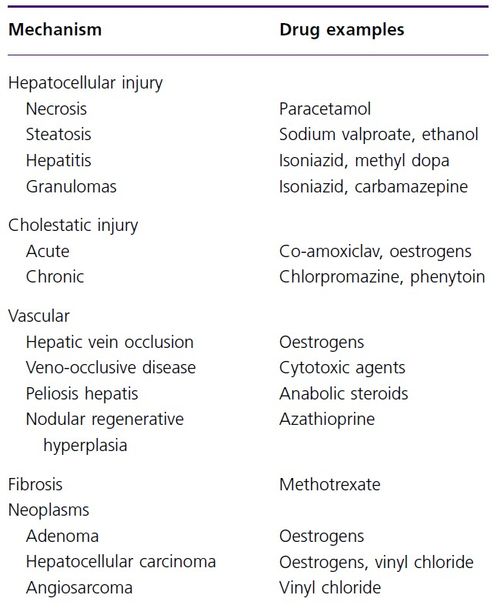
Two main categories are commonly found:
• Hepatocellular damage: Damage to the hepatocyte may be acute or chronic. The types of injury vary including necrosis, steatosis and non - specific hepatitis, which may resemble autoimmune hepatitis or a granulomatous hepatitis.
• Cholestatic damage: Intrahepatic cholestasis is a common manifestation of drug - induced liver injury.
Symptoms may mimic extrahepatic biliary obstruction but there is an absence of duct dilatation on ultrasound imaging. Histology may reveal evidence of inflammation in the portal regions which can be accompanied by destruction and loss of bile ducts.

Clinical features of drug - induced liver injury and management
Symptoms are generally non - specific, making diagnosis difficult and a high index of suspicion required to diagnose drug - induced liver injury. Many drugs cause an illness similar to viral hepatitis with a prodrome of nausea and anorexia followed by abdominal pain and jaundice. Drugs that cause hypersensitivity reactions may cause fever, rash and arthralgia.
Diagnosis may be difficult since the clinical symptoms and any changes in laboratory indices are non - specific. Often the diagnosis is suspected merely because the patient improves when the drug is discontinued; however, some drug - related injuries continue to deteriorate despite drug withdrawal. Furthermore, patients are often on multiple drugs and have serious underlying illnesses making it difficult to identify the cause of liver injury.
The key component to making a diagnosis is a careful and thorough history of recent and past drug exposure including non- prescribed medications.
The main treatment is withdrawal of the injurious agent and supportive care for symptoms such as pruritus. Most patients will recover completely although a few continue to deteriorate, and in some liver transplantation may ultimately be necessary.

Vascular pathophysiology in liver disease
Hepatic ischaemia
The liver has a dual blood supply with approximately 70 – 80% of blood flow derived from the portal vein and the remainder from the hepatic artery.
Therefore the liver is relatively well protected from ischaemia due to systemic hypotension. However, the combination of hepatic congestion and hypotension can provoke hepatic ischaemia.
The most common scenario for this to occur is in cardiac patients, where longstanding cardiac failure causes hepatic congestion, and who then have an acute
hypotensive episode; in essence there is ‘ forward failure ’ and ‘ backward congestion ’ .
Hypoxia or anaemia will further aggravate hepatic ischaemia.
• Acute hepatic ischaemia may be asymptomatic and associated with a large increase in transaminases (can approach 1000 iU/L) and reduced synthetic function. In the majority of cases this will resolve with conservative treatment within 7 days but in a small proportion of cases acute liver failure may ensue.
• In chronic cardiac congestion liver cirrhosis may result. The resulting congestion in the centilobular region and sinusoidal dilatation leads to the ‘ nutmeg ’ appearance seen at autopsy.

Portal hypertension and haemodynamics in cirrhosis
Portal hypertension is defined by an elevated portal pressure greater than the normal value of 1 – 5 mmHg. In general, portal pressure becomes clinically significant above a level of 12 mmHg. The major complications of portal hypertension include ascites, gastrointestinal haemorrhage and renal dysfunction.
Of these, gastrointestinal haemorrhage is the most dramatic and occurs frequently. Prospective studies suggest that 90% of patients with cirrhosis will develop oesophageal varices and a third of these will bleed.
Ascites can occur insidiously and it is associated with a 2 - year survival of 50%; therefore it represents a landmark event in the evolution of cirrhosis.
The normal haemodynamics are altered in cirrhosis, as outlined below, and this underpins many of the complications of portal hypertension. Overall there is increased sodium and water, but the fluid is in the ‘wrong compartment’ and the homeostatic mechanisms the body employs to correct this, e.g activation of
the rennin – angiotensin system, exacerbates the vicious cycle of events.
The haemodynamics of liver cirrhosis
• Reduced blood pressure and increased heart rate:
- low blood pressure due to reduced resistance of the peripheral circulation (systemic vascular resistance);
- cardiac output and pulse rate may rise in early cirrhosis due to activation of the sympathetic nervous system
• Increased total blood volume but reduced central blood volume:
- increased renal water and sodium retention
- increased ADH release
- splanchnic arterial vasodilatation results in pooling of blood in the splanchnic circulation
• Reduced renal blood flow:
- risk of hepatorenal syndrome
• Hepatic venous pressure gradient:
- the pressure across the sinusoids is known as the hepatic venous pressure gradient and is the pressure difference between the hepatic vein and portal vein.
In cirrhosis, there is a relationship between this gradient and the development of complications, e.g. bleeding from varices
- changes in liver architecture increase the resistance of blood flow within the liver
- increased blood flow in the portal vein (due to pooling of blood in splanchnic circulation) will also increase portal hypertension (Pressure = Resistance × Flow).

