Ministry of Health of Ukraine
Bukovinian State Medical University

Fundamentals of internal medicine: diagnostics, treatment and prevention of main musculoskeletal system disorders and connective tissue diseases

Textbook

Edited by prof. Fediv O.I.

Chernivtsi, 2013

ANKYLOSING
SPONDYLITIS
AND
OTHER
SPONDYLOARTHROPATHIES.
Spondyloarthropathies or “spondyloarthritides” are seronegative
arthritis syndromes characterized clinically by back pain, extra-articular disorders, and peripheral arthritis. These disorders show familial aggregation and are typically associated with HLA genes of the major histocompatibility complex, particularly HLA-B27. Enthesitis, inflammatory lesion at the insertion of tendon into bone, is the hallmark clinical feature of spondyloarthropathies.
Spondyloarthropathies (SA)
Seronegative spondyloarthropathy (SSA) is a group of disorders characterized by predominant below-waist asymmetrical chronic inflammatory arthritis usually with clinical or subclinical sacroiliitis and enthesopathy. These disorders have a strong familial incidence and are closely linked to HLA B27.
The concept of SSA is thus based upon clustering of the following features:
- Sacroiliitis
- Peripheral inflammatory arthritis (asymmetrical)
- Enthesopathy
- Mucocutaneous lesions
- Clinical overlap amongst the members
- Absence of rheumatoid factors
- Tendency to familial aggregation
- Association with HLA B27
Diagnostic criteria for SA (European Group on spondyloarthropathies, 1991)

Major criteria
- Pain in the spine. In the history of disease pain in the spine, which has at least 4 of the following signs:
- appearance at the age of 45 years;
- a smooth start;
- reducing the severity with movements;
- morning stiffness;
- 3 months duration.

- Synovitis. In the past, or now - asymmetric arthritis predominantly arthritis of the joints of the lower extremities.

Minor criteria
- Family history: the presence of relatives in the first or second degree with:
- ankylosing spondylitis;
- psoriasis;
- reactive arthritis;
- acute uveitis;
- inflammatory bowel disease.
- Psoriasis in the past or now, diagnosed by a doctor.
- Inflammatory bowel disease: in the past or now Crohn's disease or ulcerative colitis, diagnosed by the doctor, confirmed by X-ray or endoscopically.
The pain in gluteal areas: in the past or now, pain alternating in the right and left gluteal areas.
If there is one major and one minor criteria SA can be diagnosed. Sensitivity is 87%, specificity - 87%.
Ankylosing spondylitis (Bechterew's disease)
Ankylosing spondylitis (Bechterew's disease) - a chronic systemic disease of the joints, primarily the spine, with restrict of its mobility by ankylosing of apofizial joints, syndesmofyt formation and calcification of spinal ligaments.
The etiology of the disease is not clear. Of great importance in its development is genetic determination, genetic marker HLA B27 (90 - 95% of cases).
Pathogenesis.
According to the first receptor theory antigen HLA B27 is a receptor
for damage etiological factor (bacterial antigen, virus, etc.). The resulting complex leads to the synthesis of cytotoxic T-lymphocytes that can damage cells and tissues where the antigen B 27 are located.
The second theory of molecular mimicry is that bacterial antigen in combination with a second molecule HLA may be similar to HLA B27 properties and reduce the immune response to a peptide that causes the disease (the phenomenon of immune tolerance).

Diagnostic criteria for SA (Amor B. et al, 1990)
Number | Criterion | Diagnostic value of  criterion
Clinical symptoms or a history
1 | Night pain and / or morning stiffness in the lumbar and thoracic spine | 1
2 | Asymmetric oligoarthritis | 2
3 | Pain in the gluteal area (alternating) | 1(2)
4 | Dactylitis | 2
5 | Pain in the heel area or other signs of entezopathies | 2
6 | Acute anterior uveitis | 2
7 | Nongonococcal urethritis or cervicitis 1 month before the appearance of arthritis | 1
8 | Acute diarrhea 1 month before the arthritis | 1
9 | Psoriasis or balanitis, or bowel disease | 2
X-ray data
10 | Bilateral sacroiliitis stage II or unilateral sacroiliitis stage III | 2
Genetic predisposition
11 | The presence of the antigen HLA B27 and / or the presence of ankilosing spondylitis, reactive arthritis, uveitis, psoriasis or bowel  disease in relatives | 2
The effectiveness of treatment
12 | Significant improvement of patient’s feelings within 48 h after administration of NSAIDs or rapid increase in the severity of pain after  withdrawal of it | 2
More than 6 of 12 above criteria establish the diagnosis of SA. Sensitivity is 90%, specificity – 86,6%.

As a result of the growing process of immunoinflammation of lumbar lesion, hip joints, in the future - other joints, with the development of active fibroplastic process and formation of fibrous scar tissue with subsequent calcification and ossification. Subsequently, developing fibrous and cystic ankylosis of joint axial skeleton, at least - peripheral joints with ossification of ligaments of the spine.

Clinical classification
(Recommended by Ukraine Rheumatologists Association, 2005)
  - Forms:
The central (axial). Lesions of the spine and axial joints (shoulder, hip) without destruction of peripheral joints.
Peripheral. Lesions of peripheral joints separately or in combination with lesions of the spine and axial joints.
Visceral. Combination of central or peripheral forms of lesions of internal organs (aortytis, etc.).
  - Course:
slowly progressive
slowly progressive with periods of exacerbation rapidly progressive
  - Clinical and radiological stages: I (initial or early)
Moderate limitation of movement in the spine, or in the affected joints, radiographic changes are absent or are unclear and unequal surfaces sacral iliac joints, subchondral osteosclerosis, expansion of joint gaps.
- (moderate lesions)
Restrictions of movements in the spine or peripheral joints, narrowing gaps sacral iliac joints or partial ankilosing, narrowing of intervertebral joint cracks or signs of ankylosis of the joints of the spine.
- (late)
A significant limitation of motion in the spine or large joints of the extremities due to ankilosing, bone ankylosis of sacral iliac joints between vertebral and rib-vertebral joints or the presence of ossification ligaments.
Level of activity
0 (none) - no stiffness and pain in the spine and joints of the extremities, ESR to 20 mm/h, CRP- negative
- (minimum) - a small stiffness, pain in the spine and joints of the extremities in the morning, ESR to 20mm/h, CRP +
- (moderate) - constant pain in the spine and joints of extremities, morning stiffness for a few hours, ESR to 40mm/h, CRP ++
- (pronounced) - constant pain in the spine and joints of the limbs, stiffness throughout the day, exudative changes in the joints, low-grade temperature, visceral manifestations, ESR over 40mm/h, CRP + + + / + + +
+.
The degree of functional failure
- - changing physiological bends and limited mobility of the spine and joints of limbs, self-preserved or slightly raised.

- - a significant limitation of mobility of the spine and joints of the limbs as a result, patients must change occupation, self-service has been compromised.
- - ankylosis of all parts of the spine and hip joints, loss of working ability, inability to help himself.
Diagnostic criteria of ankylosing spondilities Rome criteria
- Pain in the buttocks - 3 months, permanent without movements.
- Pain and stiffness in the chest.
- Limitation of motion of the lumbar spine.
- Limitation of chest excursion.
- Iritis acute or from history.
- Double-sided sacroiliitis with X-ray.
Diagnosis is sure in the presence of 2-lateral sacroiliitis and one of the clinical criteria or in the presence of 4 out of 5 criteria.
New York criteria
- Limitation of mobility of the lumbar spine in all planes.
- Presence currently or from history of pain in the lumbar spine and lumbosacral junction.
- Excursion of chest <2.5 cm in height of fourth intercostal space.
- X-ray data: bilateral sacroiliitis III-IV stages, unilateral sacroiliitis stage III-IV or bilateral sacroiliitis second stage.
Credible AS in the presence of:
  - sacroiliitis III - IV stages and one of the clinical criteria
  - 2-sided stage II sacroiliitis or unilateral sacroiliitis stage III-IV with criteria of 1 or two criteria 2 and 3.
Modified New York criteria
- Pain in the buttocks for 3 months, which decreases with exercise, at rest, constant.
- Restricted mobility of the lumbar spine in the sagittal and frontal planes.
- Less excursions of the chest against the rules corresponding to age and sex.
- X-ray data: bilateral sacroiliitis II-IV stage or unilateral sacroiliitis III-IV stages.
Credible AS in the presence of unilateral sacroiliitis stage III-IV or bilateral sacroiliitis stage II-IV and one of the clinical criteria.

Diagnostic criteria proposed by the European Group for the Study of spondyloarthropathies
Major criteria
Pain in the spine.
In the history of pain in the spine with the following characteristics (at least 4 of 5)
- The appearance of pain at the age of 45 years
- Invisible beginning
- Reduction in movements
- Morning stiffness
- A minimum of 3 months.
2. Synovitis.
In the history or present asymmetric arthritis usually joints of lowe
limbs.
Minor criteria
- Family history (presence of relatives in the first and second degree ankylosing spondylitis, psoriasis, rheumatoid arthritis, acute uveitis, inflammatory bowel disease).
- Psoriasis in history, diagnosed by a doctor.
- Inflammatory bowel disease (Crohn's disease, ulcerative colitis, diagnosed and the doctor confirmed radiographically and endoscopically).
- Endures pain in the buttocks.
- Entezopathies (pain and sensitivity in the area of attachment of the tendon or plantar fascia)
- Acute diarrhea (diarrhea episode per month before the arthritis).
- Urethritis (nongonococcal urethritis or cervicitis month before the appearance of arthritis).
- Radiographically defined sacroiliitis:
0 - no sacroiliitis, I - possible sacroiliitis, II - minimal sacroiliitis, III - moderate, IV - ankylosis.
The presence of one large and one small criteria allows diagnosis spondyloarthropathies.
Standard criteria for diagnosis of lesions of various organs in patients with ankylosing osteoarthritis
A. Criteria for bone lesion systems: ankylosis of the hip and lumbar- intervertebral joints, lesions of the shoulder joint. Peripheral joints are affected in 10 - 15% of patients, other less common arthritis. Peripheral arthritis in 20 - 25% can pass without a trace.
- Criteria of eye damage: iritis, iridocyclitis, anterior uveitis, episcleritis.

- Criteria damage the circulatory system: inflammation of the ascending aortic arch, aortic insufficiency, pericarditis, cardiomegaly, arrhythmias and conduction of the heart.
- Criteria for lung lesions: bilateral progressive fibrosis of the apical segments of the lungs.
- The criteria for renal involvement: secondary amyloidosis, IgA- nephropathy
- Criteria nervous system: syndrome of "horse tail", effects (myelopathy) of atlanto-axial subluxation, fractures of C5 - C6 vertebrae with the development of paraplegia.
Laboratory criteria for disease:
A. In blood leukocytosis, increased ESR, hypochromic anemia
- There is increased content of sialic acid, seromucoid, CRP, hepatohlobin, α2-globulin
- The absence of rheumatoid factor in blood
- In the case of renal involvement - proteinuria, erytrotsyturia, izostenuria, cylindruria.
- Detection of HLA B27.
Standard treatment of ankylosing spondylitis
Kinesotherapy (movement therapy) is a leader in preserving the mobility of the spine, its landings, activate diaphragmatic breathing through breathing exercises 1 - 2 times a day for 30 minutes, therapeutic exercise performed 3 - 4 times a day.
Reduce pain and inflammation in the spine and joints:
- Derivative of pirazolon (phenylbutazone, oksyfenilbutazon, azapronol, fenpropazol) combined drugs: reopiryn, pirabutol, amebic, perklyuzon
- NSAIDs:
  - COX-2-selective:
    - Meloxicam (Movalis) 7.5 - 15 mg / day,
    - Nimesulide 100 mg twice a day,
    - Celecoxib (Celebrex) 200 mg 1 - 2 times a day,
    - Rofecoxib 12.5 mg per day.
  - Nonselective:
    - Diclofenac sodium (voltaren) 100 - 150 mg / day,
    - Diclofenac potassium - 100 - 150 mg / day, Others.
- glucocorticosteroids (prednisolone, methylprednisolone at equivalent doses):

- system:
- 10 - 40 mg equivalent prednisone short course with high inflammatory activity,
- 10 mg equivalent prednisolone prolonged persistent high inflammatory activity and the ineffectiveness of NSAIDs and sulfonamides,
- Pulse therapy - 1000 mg methylprednisolone daily for 3 days.
- local therapy:
- Methylprednisolone, intra diprospan in mono/oligoarthritis of large peripheral joints (except hip injury).
- enzymes (Vobenzim 10-15 tabs 3 times a day - increases the effectiveness of anti-inflammatory drugs).
Basic therapy with the use of sulfanilamide, cytostatics and glucocorticosteroids:
- sulphasalasyne or salazopirydyn by 1g twice daily (40 mg / kg / day), followed by a decrease in drug dosage to 500 - 1000 mg / day for 4 - 6 months
- D-penicillamine 600 mg / day, later - 150 - 300 mg / day for 3 - 4 months
- azathioprine, 100 - 150 mg / day
- Methotrexate by 7.5 - 15 mg / week
- Chlorbutinum (leykeran) of 4 - 6 mg / day
- Prednisolone, 20 - 40 mg / day to achieve the effect, pulse therapy - in / 1000 mg methyl prednisolone daily for 3 days
- Local methylprednisolone, dyprospan intraarticulary at mono-and oligoarthritis in large peripheral joints (except for patients with lesions of the hip joints)
In order to reduce muscle spasm and abnormal muscle tension is prescribed:
- Mydocalm - 100 - 150 mg / day
- Syrdalud - 4 - 6 mg / day
- Izopteran - 75 mg / day
Improvement of microcirculation and blood supply to cartilage and

bone:

- nifedipine (korinfar) retard on 20 - 40 mg / day
- Pentoxyfilline (trental) by 3 table/ day or 5 ml / in drip
- Nicotinic acid 1 ml of 1% solution of the scheme: 1-day -1 ml ,2-day

  - 2 ml, 3-Day - 3 mL (daily dose increased to 1 ml to 10 ml per 10-day)
Surgical treatment (synovektomiya, endoprothesis of joints, vertebrotomiya)
Physiotherapy (ultrasound, diadynamophoresis with aspirin, inductothermy, reflexology, magnetotherapy, balneotherapy)

Treatment quality criteria:
Normalization or reduction of clinical and laboratory parameters of
disease activity.
Decrease (slow) radiological progression of lesions of the musculoskeletal system.
Prevention
Primary prevention has not been developed.
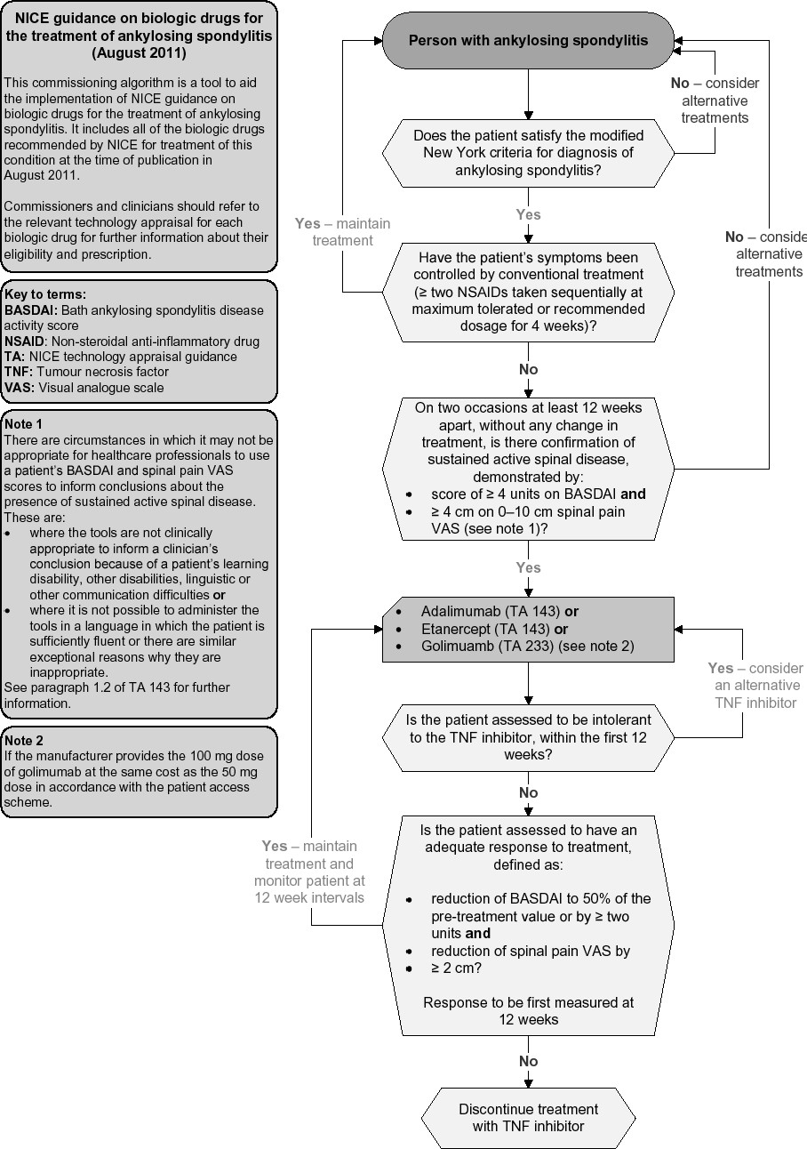
For the purpose of secondary prevention of acute disease used NSAIDs, glucocorticosteroids in small doses over months and yea

