Basics revision in Hematology
The cellular elements in the blood are continuously destroyed and replaced. What process is required to continuously replace them and keep the number of cells within well-defined limits?
The numbers of cells produced in an individual with a lifespan of 80–90 years is astronomical (12 × 10⁶ granu-locytes are produced each day). In order to maintain haemopoiesis throughout life, a pool of resting haemo-poietic stem cells (HSCs) is required. These cells, given the appropriate stimulus, can differentiate along specific pathways and produce the mature cells of the peripheral blood. Because the pool of resting stem cells must be maintained at all times, these cells must be capable of self-replication and production of progeny. Each stem cell has the capacity to differentiate into any of the cells in the blood. Hence, these stem cells are ‘pluripotent’ and capable of self-renewal (Fig. 1).
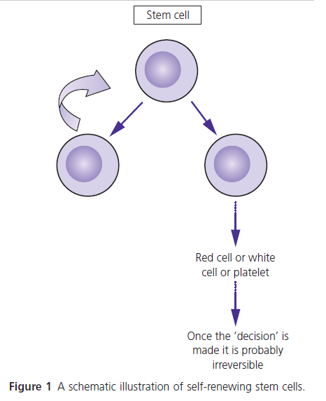
Where else are HSCs found besides the bone marrow?
HSCs are found in very small numbers in the peripheral blood and in large numbers in umbilical cord blood. HSCs have the appearance of a small lymphocyte.

What tragic event served as a major stimulus to stem cell research?
Much of the research that led to our understanding of haemopoiesis came from the knowledge that ionizing radiation resulted in the death of experimental animals from infection or bleeding. Thus, the development of the atom bomb served as a stimulus for many experiments. This ultimately resulted in a therapeutic manoeuvre (allogeneic stem cell transplantation), which was to test all the theories of haemopoiesis.

How does stem cell transplantation verify the existence of pluripotent stem cells?
In animals, experiments can be carried out when the HSC donor is of a different sex from the recipient. The animal is initially exposed to irradiation in order to kill all the HSCs. The animal is then ‘rescued’ by injecting bone marrow cells from the donor. Haemopoiesis recovers but all of the haemopoietic cells in the bone marrow and blood of the recipient are derived from the donor. These survivors were called ‘radiation chimaeras’ after the mythological creature, which had the head of a lion, the body of a goat and the tail of a snake (Fig. 2). Human chimaeras are created when a patient receives HSCs from a healthy donor.
Figure 2 Chimaera. A mythological fi gure with the body of a goat, head of a lion and tail of a snake.
First used when mice were successfully transplanted with haemopoietic stem cells. Now used in humans after stem cell transplant to denote cells of donor or recipient origin.

What are the names of the mature blood cells in the circulation?
Erythrocytes, neutrophils, eosinophils, basophils, mono-cytes (Fig. 3a–f) and platelets. Erythrocytes are derived from a nucleated cell in the bone marrow called a nor-moblast, which undergoes a number of divisions and extrudes its nucleus before being released into the blood. Granulocytes (neutrophils, eosinophils, basophils) and monocytes are likewise derived from a nucleated cell, but lymphocytes appear to be derived from a nucleated cell, which ‘differentiates’ at a very early stage. Platelets are derived from giant cells called megakaryocytes.
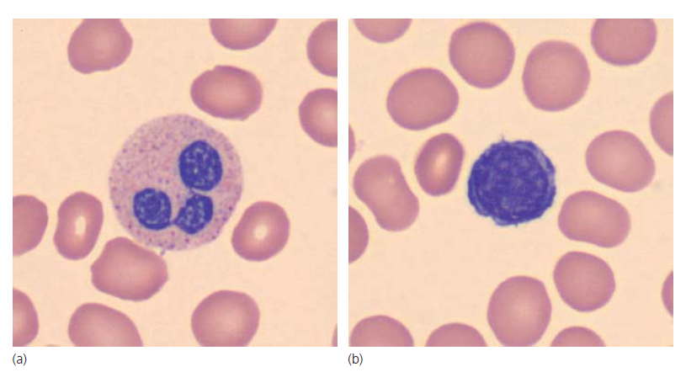
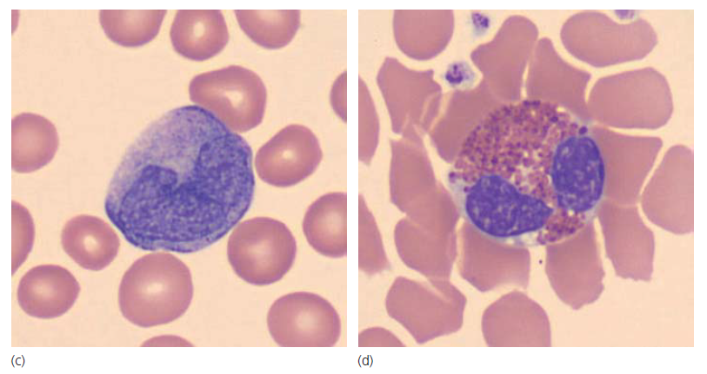
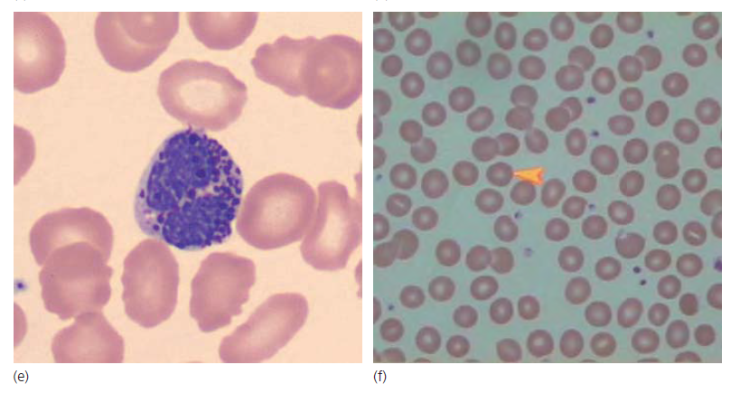
Figure 3 (a) Neutrophil, (b) lymphocyte, (c) monocyte, (d) eosinophil, (e) basophil and (f) normal erythrocyte.

What test is commonly used clinically to measure the frequency of HSCs in humans?
There is no commonly used test available. It is estimated that HSCs occur at the frequency of 1 in 1 million nucle-ated cells in the bone marrow. Most laboratories depend on a test that measures the ‘committed pool’ of cells, i.e. primitive cells that are already committed to a particular lineage such as a red cell or a granulocyte. Mononuclear cells from the bone marrow, umbilical cord blood or peripheral blood are put into a semi-solid supporting matrix and cytokines/growth factors are added. Follow-ing in vitro incubation for a variable number of days, large groups of cells appear (colonies) and have the appearance of mature blood elements, e.g. red cells. Each colony represents growth from a single progenitor.
Figure 4 shows a colony of mature red cells and white cells known as a colony-forming unit – granulocyte, mac-rophage (CFU-GM).
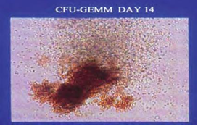
Figure 4 A colony of red cells and neutrophils grown in the laboratory and derived from a single stem cell.

Figure 5 shows the different cell lineages and how they are measured. Each term, e.g. burst-forming unit – erythroid (BFU-E), refers to a colony of cells derived from a stem cell and which grows in the laboratory into a recognizable mature cell, in this case a red cell. Each colony is derived from a single stem cell.
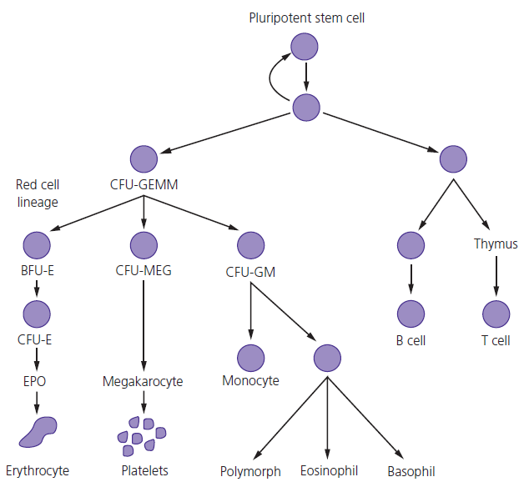
Figure 5 A schematic illustration of the different cell types, all derived from a pluripotent stem cell.

The CD34 antigen (identified by flow cytometry) is an important clinical marker as it is a principal indicator of a pluripotent stem cell. It is expressed on haemopoietic stem cells and committed progenitor cells. The CD34⁺ cell count is used to guide physicians when cells are being collected for stem cell transplantation.

How does a HSC differentiate into a mature blood cell?
The precise mechanism is unknown. However, it seems that cell–cell interactions (progenitors interact with mes-enchymal cells in the bone marrow) and the expression of a large number of genes are important. Cytokines and growth factors may act in combination to activate signal transduction mechanisms. These intracellular factors activate the nucleus and stimulate the transcription of regulatory genes. These genes, in turn, influence prolif-eration, differentiation, apoptosis (programmed cell death) and development of mature cell function.

How can we recognize the potential for differentiation of HSCs?
HSCs and differentiating progenitors express antigens on their cell surface. The antigen type and frequency will change as the cell ‘differentiates’. These antigens can be identified by a technique called ‘flow cytometry’. The expression of different antigens allows us to identify pro-genitors of different lineages and to chart the develop-ment and differentiation of blood cells.
The type of cell, i.e. its lineage, can be determined by the antigens on its surface. In many malignancies there is an accumulation of normal antigens in abnormal amounts.

Flow cytometry, or immunophenotyping, is made possible by the use of flow cytometers using the principle of hydrodynamic focusing (Fig. 6).
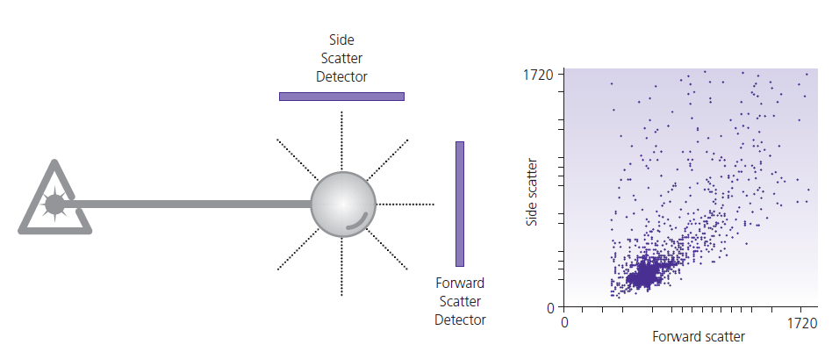
Figure 6 Flow cytometry or immunophenotyping, a method of identifying antigens on cells and thus establishing their lineage.
The sample is injected, forcing the cell into the centre of the stream. As the cells intercept the light source they scatter the light and fluor-ochromes are excited to a higher energy state. This energy is released as a photon of light. The flow cytometer meas-ures fluorescence per cell. After the different signals or pulses are amplified they are processed by an analogue to digital converter (ADC), which in turn allows for events to be plotted on a graphical scale (Fig. 7).
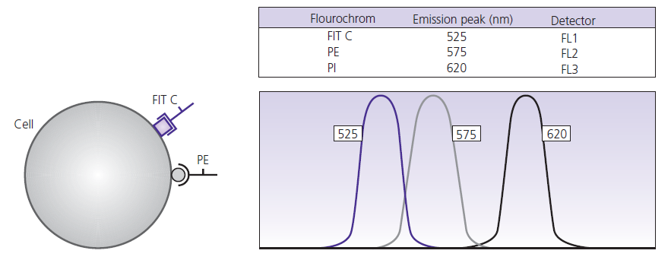
Figure 7 Flow cytometry or immunophenotyping showing the identifi cation of antigens on cell surface using antibodies labelled with fluorochromes

Which cytokines or growth factors commonly found in the blood are available for clinical use?
Erythropoietin
Erythropoietin (EPO), a polypeptide, is the best known and is the main cytokine involved in erythrocyte differ-entiation, proliferation and apoptosis. It is largely pro-duced in the kidney (Case 16). EPO production responds to hypoxia via a transcription factor complex called hypoxia inducible factor 1 (HIFI). A recombinant form is available and is used in the treatment of the anaemia of renal failure.
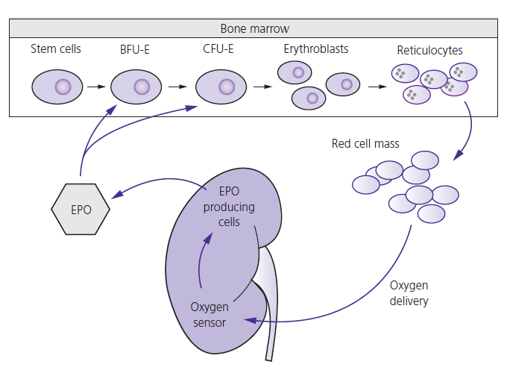
Interactions between erythropoietin (EPO), the kidney and oxygenation. BFU-E, burst-forming unit erythroid; CFU-E, colony-forming unit erythroid.

Granulocyte colony-stimulating factor
Granulocyte colony-stimulating factor (G-CSF) and granulocyte–macrophage colony-stimulating factor (GM-CSF) are glycopeptides and are secreted by granu-locytes, monocytes, T lymphocytes, fibroblasts and endothelial cells. These growth factors are responsible for the production of granulocytes (G-CSF), granulo-cytes, eosinophils and monocytes (GM-CSF). The recombinant form of G-CSF is used in the treatment of congenital neutropenia and to ‘mobilize’ stem cells from the bone marrow into the peripheral circulation where they can be easily collected and used for stem cell transplantation.
Thrombopoietin
Thrombopoietin (TPO) is a glycoprotein produced by the liver. It stimulates stem cell and platelet production. Newer formulations of recombinant TPO should soon be available to treat thrombocytopenia.
Stem cell factor
Stem cell factor is a glycoprotein produced by stromal cells and binds to the receptor c-Kit. It is essential for stem cell differentiation and proliferation.

How does apoptosis (programmed cell death) affect haemopoietic cells?
Apoptosis (programmed cell death) is a complex event, which terminates with the activation of caspases, DNA fragmentation and phagocytosis.
What is meant by the term stem cell plasticity?
Under experimental circumstances human pluripotent haemopoietic stem cells may be made to differentiate into non-haemopoietic tissues of mesenchymal origin such as muscle or cartilage. Whether this phenomenon can be reproduced in patients is unclear to date.

What major events occur during red cell (erythrocyte) development?
Fetal erythropoiesis develops in the yolk sac perhaps from a common progenitor with the endothelial cell known as the haemangioblast. The liver then predomi-nates as the site of haemopoiesis followed by a period when the cells circulate and finally in the last 3 months of fetal life the bone marrow predominates as the major site of haemopoiesis. Haemoglobin (Hb) synthesis in fetal life differs from childhood and adult Hb. It seems that undifferentiated stem cells contain most of the genes associated with the different cell lineages but over time many genes become silent and others are tran-scribed at a higher level. The first recognizable red cell precursor is a nucleated ‘normoblast’. Following cell division these cells become smaller, develop haemoglobi-nized cytoplasm and eventually extrude their nucleus. A mature erythrocyte is a non-nucleated biconcave disc.

As red cells precursors mature, gene expression is up-regulated for blood group antigens, membrane proteins, glycolytic and haem synthetic enzymes. The final two steps are the synthesis of globin chains and haem. About 2% of circulating red cells are non-nucleated but not biconcave discs. They are larger than mature red cells, contain ribosomes and synthesize small amounts of Hb. They are called reticulocytes and mature into erythro-cytes after about 48 hours.
Red cell lifespan is 120 days. Erythrocyte production rate is approximately 10¹⁰ per hour. EPO is the most important growth factor. EPO, following any hypoxic stimulus, binds to trans-membrane receptors and triggers a signalling system that results in red cell proliferation and inhibition of apoptosis. A critical factor is the activation of the JAK-2 kinase. Mutations in JAK-2 are now fundamental to our understanding of diseases in which proliferation of red cells, white cells and platelets predominate

What is the main function of the immune system and what cells predominate?
The immune system has a fundamental function in regu-lating defence mechanisms against foreign attacks, pri-marily infective agents. In addition, it also has an important role in the development of cancers (malig-nancy). The effectors of the immune system are repre-sented by lymphocytes. We identify and recognize different types of lymphocytes (known as subsets) which have various intrinsic functional properties.

Lymphocytes with different functions originate from pluripotent stem cells. Humoral responses are mediated by B lymphocytes through their capacity to produce and secrete specific antibodies. Cell-mediated immunity is regulated by T lym-phocytes. During the process of physiologic develop-ment, common lymphocyte progenitors, which are derived from pluripotent stem cells, differentiate in lymphoid organs, including fetal liver and bone marrow in the case of B lymphocytes and the thymus for T lymphocytes. There is a third population of lymphocytes named natural killer (NK) cells which mediate responses against virus-infected and tumour cells.

What was the major discovery that allowed us to unravel the functional subsets of lymphocytes in the human immune system?
The turning point was the development of the mono-clonal antibody (MoAb) technology in 1975 by Köhler and Milstein (who later won the Nobel Prize for Medi-cine) which rapidly led to the production of MoAbs directed against antigens expressed by different lym-phocyte subsets (B, T, NK). This collection of antigens is known as the ‘immunophenotypic’ profile.

MoAbs were grouped according to the antigen identi-fied. Thus, all the MoAbs directed against a well-defined antigen are identified according to a cluster of differen-tiation (CD). A table showing the MoAbs frequently used to identify different lymphocyte subsets is shown below.
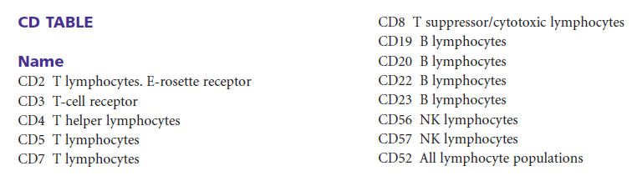
What is the major function of B-lymphocytes?
B-lymphocytes are important in ‘humoral immunity’. They produce antibodies also called immunoglobulins (Igs). These are glycoproteins that bind to specific antigens, neutrophils, lymphocytes and basophils. The antigen is initially processed by antigen presenting cells (APCs, monocytes and macrophages) and T cells are acti-vated. In turn, the B lymphocyte proliferates and differ-entiates into a plasma cell, which produces specific antibody which will destroy or opsonize the antigen.

What is meant by the term “opsonization”?
Opsonisation is when antibodies make a pathogen ready for digestion.
What laboratory technique is used to identify lymphocyte subsets?
Flow cytometry (Fig. 8).
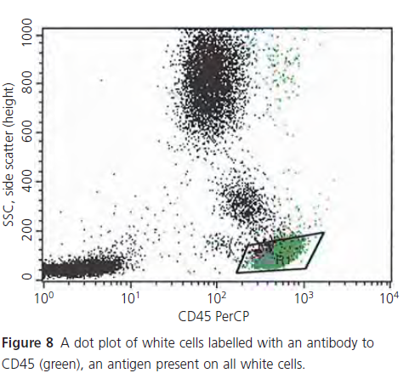
How do B cells recognize antigens and produce specific antibodies?
Each antibody (Ig) molecule has two heavy and two light chains. During early development in the bone marrow the genes for heavy and light chains are rearranged in that order. Once rearrangement is complete, the cell will express the antibody molecule on its surface. Mature B lymphocytes express IgM and IgD on their cell surface, which is important for cell survival. The cell surface antigen profile is shown in Table 1. Maturing B lym-phocytes leave the bone marrow and migrate to lymph nodes where they congregate in an area called the germi-nal centre. Having recognized an antigen by binding to it, the B lymphocyte then undergoes a process called somatic hypermutation, i.e. mutations (rearrangements) occur in the variable region genes. The cells will divide and proliferate into plasma cells or B memory cells and produce specific antibody, as shown in Table 1.
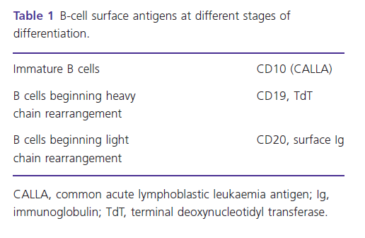
How do T cells exert their function?
T cells are important in ‘cell mediated immunity’. T-cell maturation occurs in the thymus. There are four T-cell receptor (TCRs) genes: α, β, γ and δ. Like in the B lym-phocyte, the TCR genes undergo rearrangement so that a mature T cell will only express α/β or γ/δ (5%) recep-tors on its surface. The TCR recognizes a major histo-compatibility complex (MHC) molecule and the T cell leaves the thymus. T memory cells provide the immune system with a memory so that these cells will rapidly proliferate if subsequently exposed to the same antigen.

What major events take place during white blood cell development?
Granulocytes are white blood cells (WBCs), neutrophils, eosinophils and basophils found in the circulation. Gran-ulocytes are derived from haemopoietic stem cells in the bone marrow under the influence of cytokines (G-CSF is the most important). Neutrophils have a lifespan of around 7 hours in the circulation and leave the circula-tion as part of the inflammatory reaction. There is a large reserve of granulocyte precursors in the bone marrow. Normal individuals can increase the production of WBCs by 10–20 times. Approximately 50% of the granulocytes and monocytes are ‘marginating’, i.e. adherent to the sidewall of blood vessels but are ‘available’ if required. The predominant granulocyte is the neutrophil and its function is phagocytosis of microorganisms.
Following bacterial infection, neutrophils are attracted by chemotactic factors. Neutrophils ingest antibody and complement-coated bacteria to form a phagosome. The neutrophil degranulates and various enzymes are released. H₂O₂ is produced and interacts with O₂⁻ in the presence of iron to generate singlet oxygen and hydroxyl radicals, both of which are toxic to bacteria.
What other types of granulocytes are present in the circulation?
Eosinophils and basophils are also derived from haemo-poietic stem cells in the bone marrow. Eosinophils are important in the response to parasitic infection, allergy and drug reactions. Basophils are also implicated in allergy and drug reactions.

What other WBCs besides granulocytes are important and what is their function?
Monocytes are also derived from a haemopoietic stem cell in the bone marrow under the influence of the cytokine GM-CSF and are very closely related to granu-locytes. They have a similar phagocytic and killing func-tion (enhanced by GM-CSF), and are found in the spleen and liver as well as the circulation.
What other cells are found in the blood besides erythrocytes and white cells?
Platelets. These are very small non-nucleated structures derived from the ‘shedding’ of the cytoplasm of giant cells in the bone marrow called megakaryocytes. Meg-akaryocytes are polyploid (increased DNA content) and have multilobed nuclei. Unlike other bone marrow cells, megakaryocytes become larger as they mature. Platelets have a lifespan of about 7 days.

What is the function of platelets?
The principal function of platelets is to enhance the gen-eration of thrombin (blood clotting). They do this by acting as a catalytic surface. The important structural elements of this catalytic surface include:
(i) plasma membranes rich in glycoproteins and phospholipids;
and (ii) secretory granules.
The plasma membrane is a highly reactive surface on which haemostatic (procoagu-lation and anticoagulation) reactions can take place. The plasma membrane is predominantly in deep invaginations and the main glycoproteins are GP IIb–IIIa (the most plentiful). GP IIb–IIIa acts as a receptor for fibrinogen. GP Ib–IX–V is the major von Willebrand receptor and binding is the initial step that localizes platelets to the site of vascular injury.
The phospholipids in the platelet membrane provide the surface to mediate Ca²⁺ dependent binding of vitamin K dependent coagulation factors through their γ-carboxyglutamic acid residues.
Platelet granules (α-granules, dense granules and lysosomes) contribute to platelet adhesion and aggregation, and to blood clotting.
Platelet adhesion and aggregation are sufficient to stop bleeding from small vessels. Coagulation factor activation and fibrin formation, together with platelet aggregation and adhesion, are required to stop bleeding from larger wounds.
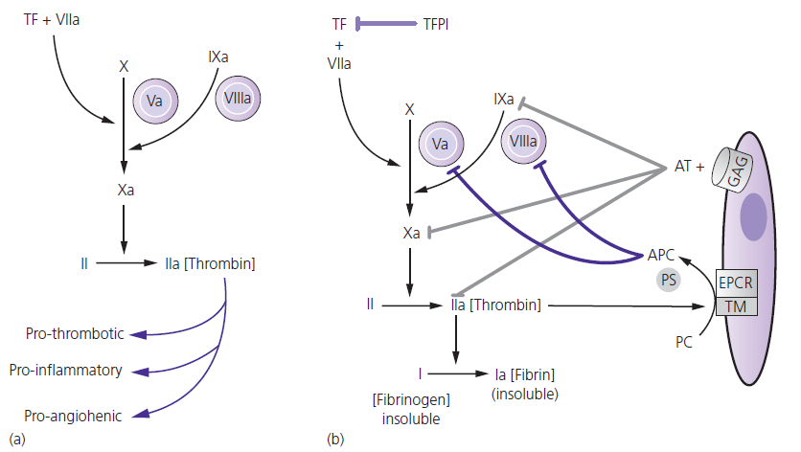
(a) Blood coagulation is initiated (initiation phase) when tissue factor (TF), expressed after injury to cell wall (e.g. endothelial, monocytic cells), is exposed to FVIIa in the bloodstream. TF–FVIIa complex in turn activates FIX to FIXa and FX to FXa. FIXa with its cofactor FVIIIa in turn also activates FX to FXa (amplifi cation phase). FXa with its cofactor FVa activates prothrombin (II) to thrombin (IIa) (propagation phase). Thrombin converts soluble fi brinogen to insoluble fi brin. Thrombin is not only prothrombotic but activates platelets and is pro-infl ammatory and promotes new vessel formation.

(b) The initiation phase of coagulation is controlled by inhibiting the complex of TF, FVIIa and FXa by tissue factor pathway inhibitor (TFPI). The amplifi cation phase of coagulation is blocked by the protein C pathway. Protein C (PC) is activated by a complex of thrombin, thrombomodulin (TM), and endothelial protein C receptor (EPCR) to activated protein C (APC) which in association with protein S (PS) inactivates FVa and FVIIa. The thrombin formed in the propagation phase is controlled by antithrombin (AT).

