Approach to the patient in Hematology
Many patients are seen initially in a primary care setting and may have vague symptoms. In the hospital the majority of patients are referred for investigation and expert opinion because of abnormal blood test results. Others are referred to the haematologist because abnor-mal blood test results occur during the diagnosis or man-agement of another apparently unrelated condition.
As always, the most important diagnostic event is the history-taking.

What should be your initial interaction with the patient?
In an ambulatory patient it is important to observe the patient’s general demeanour and ease of movement. It is important to greet the patient by asking their name while offering to shake hands at the same time. (In some cul-tures it is impolite for a man to shake hands with a woman.) You should introduce yourself by your full name and title.

Why is it important to observe the patient and what can you learn from a handshake?

You can observe if the gait is steady and if the patient is in pain when they walk. An unsteady gait might suggest a peripheral neuropathy or subacute degeneration of the spinal cord seen in vitamin B₁₂ deficiency. Pain may be bony and reflect malignant disease or a fracture such as in multiple myeloma. A dorsal kyphosis should also arouse the same suspicion. A handshake provides information about the patient’s state of mind. Excessive sweating may be the result of nervousness or hyperthyroidism. Rheumatoid disease and other forms of arthritis may be evident. As you shake hands you can carry out a rapid general inspection noting the presence of jaundice, seen in haemolysis or cyanosis, or plethora in erythrocytosis.

Why should you ask the patient their name?

Although you might know the patient’s name it is important to ask. First, simply to make sure the patient you are interviewing is who you think he/she is. Secondly, to test the patient’s memory and ability to understand and speak. Providing the patient with their name and asking for confirmation is not adequate as he/she might affirm without understanding the question. Chronic alcoholism, multiple small strokes, Alzheimer’s disease or vitamin B₁₂ deficiency can impair memory or understanding.

Why should you introduce yourself by name and title?

It is important for the patient to know your name as it provides a sense of security and gives the patient confi-dence. Your title is important as it also lets the patient know precisely with whom they are dealing. Never call a patient by their first name unless they ask you to as it conveys disrespect or over-familiarity. You can be friendly and put the patient at their ease without using first names.

Frequently a patient will ask you if they may bring a spouse, relative or friend into the interview. What should be your response?
Gently but firmly you should deny the request. A second person can often inhibit the patient from revealing certain details about their complaint to avoid embarrass-ment. Likewise you could be inhibited from asking certain questions. Tell the patient that it would be per-fectly acceptable to bring in their friend/relative at the end of the interview when you can explain the probable diagnosis and what further steps should be taken. This also provides you with an opportunity to corroborate parts of the history, which might have appeared unclear.

What should be done next?

You should ask the patient to tell you, in their own words, why they have come to see you. Be patient. Do not rush the patient or give the impression you are in a hurry. However, do not let the patient wander off and gently but firmly steer them back to their story.

Remember history-taking is the most important interaction between the doctor and the patient. At the completion of the history a differential diagnosis should be made. A small number of diagnoses will be made when an unexpected physical sign is uncovered during the examination. Even more rarely will performing laboratory tests make an unsuspected diagnosis.
What should be done after the patient has completed his/her story?

Find out how long the complaint has been present, the approximate starting date of the symptoms (it may be useful to link the starting date to a public holiday or a personal event such as the patient’s birthday) and if the symptoms are getting worse or better.
Does anything bring on or relieve them? (The pain of multiple myeloma is typically worse at night, whereas musculo-skeletal pain tends to be relieved by rest.)
Are there any associated features, such as weight loss, fever or night sweats, which are often associated with haematological malignancies? A social history should be taken with particular attention to travel (infectious diseases, e.g. malaria, may have important haematological manifestations), recreational and illicit drugs, and proprietary medications or herbal remedies.

A family history should be taken of haematological malignancy, coeliac disease, abnormalities of haemoglobin synthesis (e.g. thalassaemia or sickle cell disease or other haemoglobinopathies), diseases of iron metabolism (e.g. haemochromatosis) and autoimmune diseases.
The family history should include parents, siblings and children. Causes of death of grandparents should bedetermined, if possible.
A system review should be carried out and sexual practices should be ascertained.

A symptom is what a patient complains of, e.g. a sore throat. A sign is what the doctor finds when he/she examines a patient, e.g. an infected pharynx.

What points on general examination of the haematological patient should you be especially alert to?

Note if the patient is jaundiced (icteric) by looking at the sclera as this might imply haemolysis of ineffective erythropoiesis. A bronze colour in the skin should not be confused with icterus or jaundice as it is usually caused by iron deposition and is seen in diseases such as haemochromatosis. Cyanosis might suggest con-genital heart disease or heart failure. A plethoric face suggests erythrocytosis and pallor (palmar creases or conjunctival membranes) is common in anaemia. Spooning of the nails, koilonychia and cracking at the angles of the mouth are seen in severe iron deficiency. An unusual cause of blood loss is hereditary telangiectasiae. These may be seen in the nail beds, lips and tongue while also occurring in the gastroenterological tract.
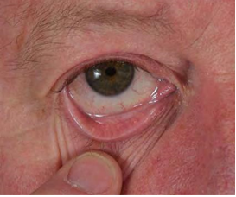
Conjunctival pallor.

Purpura, bleeding into the skin, may reflect a low platelet count although in elderly people is often present on the backs of the hands and is secondary to minor trauma together with loss of subcutaneous tissue (called senile purpura). Subconjunctival haemorrhages may result from a low platelet count and may be particularly prominent if the patient has vomited or has had a bout of coughing. Purpura does not blanch on pressure, unlike small dilated blood vessels. In chronic liver disease spider naevi may be present on the face, arms and trunk. These small dilated arterioles blanch under pressure and fill from the centre and are found in the drainage area of the superior vena cava.
Bilateral subconjunctival haemorrhages Petechial rash on the leg

Before examining a patient, always explain what you are about to do in simple language, e.g. ‘I would like to feel your tummy’ rather than ‘I would like to conduct a clinical examination of your abdomen’. Ask if the patient has any tenderness in the area to be examined and always observe the patient’s face during the examination looking for signs of pain or discomfort. Reassure the patient that you will try not to hurt them.

What other physical signs might be present on general inspection?

Enlarged lymph nodes or tonsillar enlargements may be seen in the mouth and neck in haematological malignan cies. They may also be visible in the axillae and groins.

Gum hypertrophy may be seen in leukaemia:

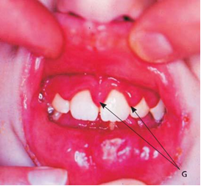

How do you approach the examination of the lymph nodes?

First ask the patient if they have noticed any lumps or bumps when dressing or washing. Ask them to undress to the waist. The patient should sit on a couch or chair. Look into an open mouth for enlargement of the tonsils. Standing in front of the patient, look to see if there are any obvious masses in the neck. Examine the lymph nodes in the head and neck. Ask the patient to. put their hands on their hips and move their elbows slightly forward.
Examination of lymph nodes
Assess the supraclavicular regions and then the axillae. Measure any enlarged lymph nodes and record size and the following characteristics: mobility, fixed or mobile; texture, hard or rubbery. Ask the patient to lie down and examine the inguinal nodes and record the characteristics above.

Lymph node enlargement, which is painful, is usually inflammatory in nature. Lymph nodes that are immobile and painless are commonly malignant.

Which abdominal organs are most likely to be enlarged in haematological diseases?
The liver and spleen. Before estimating the size of these organs look at the abdomen, loins and the back for scars. The patient may have had a splenectomy, a kidney removed or other abdominal surgery, which could influ-ence the haematological findings (e.g. a previous splenec-tomy could explain the signs of hyposplenism on the blood film).
To estimate the upper borders of the liver percuss the chest lightly from an area of resonance, over the lung, towards an area of dullness. When the percussion note changes mark the skin, with the patient’s permission. This is usually in the 5th intercostal space. The lower border of the liver should be palpated, beginning from the right iliac fossa. The liver edge can be felt during inspiration and nodules may sometimes be detectable. Mark the lower border and measure the liver span in the mid-clavicular line. In an adult the span should be 12– 15 cm. Do not comment on the size of the liver in ‘fingers’.
The spleen may sometimes be visible protruding from below the left costal margin. Stand on the right-hand side, asks the patient to take a breath and observe. The spleen is not palpable or visible in a normal individual. Begin palpation from the right iliac fossa and proceed to the left hypochondrium as the patient is breathing. The enlarged spleen will move down freely with each inspira-tion. If the spleen is markedly enlarged the notch may be palpable on the medial border. The length of the spleen should be measured from the left costal margin, in quiet inspiration and recorded in centimeters.

What radiological investigations are commonly used in the evaluation of ‘haematology patients’?
A radiograph of the chest, an ultrasound of the abdomen and a computed tomography (CT) scan of the chest and abdomen. Remember, an ultrasound does not utilize radiation and a CT examination exposes the patient to the equivalent radiation dose to approximately 800 chest radiographs.
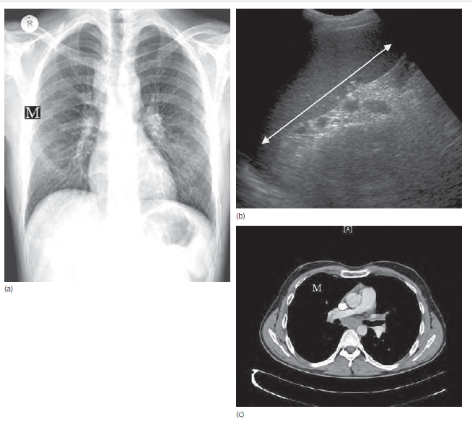
(a) Chest radiograph showing mediastinal lymphadenopathy (M). (b) An ultrasound showing an enlarged spleen. (c) A computed tomography (CT) scan showing mediastinal lymphadenopathy (M).

The haematological examination is incomplete until the results of a full blood count are assessed and a blood film is examined microscopically.

What should be done next?

Explain to the patient, in ordinary language, what you think is wrong and how serious you think it is. Clarify what type of tests you recommend and precisely how they will be carried out and when the results are likely to be available. Ascertain if the patient understands what you have said. The best way to do this is to get the patient to explain to you, in their own words, what they have understood. Ask the patient if they would now like to bring in their friend/relative and go through the same procedure with them.

In the case of an unconscious patient or one unable to give a history, a relative or friend who is familiar with the preceding events should be asked to provide the information.

What type of blood sample is required for routine analysis?

Blood taken into a tube containing the anticoagulant EDTA, a calcium chelator, is used in the majority of automated cell counters.

What parameters are commonly measured?

The number of red cells, their size/volume and hae-moglobin content are measured. The percentage of plasma is calculated. The total number of white blood cells and the number of granulocytes, monocytes, eosinophils, basophils, lymphocytes and platelets are counted.
Normal laboratory values may vary from laboratory to laboratory and country to country depending on the type of equipment used to carry out the assay and the popula-tion being tested. It is extremely important to check the reference values in the laboratory that is carrying out the test for your patient. The values given in Table 2 have been obtained from the laboratory from St. James’s Hos-pital in Dublin and are in common use in Europe. Results given in brackets are those commonly used in North America.
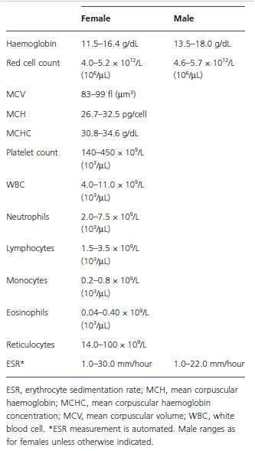
What is the value of examining the blood film?
Microscopic examination of the blood film permits the evaluation of the shape, size and colour (usually reflects the degree of haemoglobinization) of the red blood cells. It facilitates detailed examination of the appearance of the white blood cells and platelets, and it allows the iden-tification of abnormal cells, e.g. leukaemia cells (the fig. below: blood fi lm showing ‘leukaemia blasts’ (L) with large nuclei, prominent nucleoli and few other distinguishing features). It confirms the number and size of the platelets.
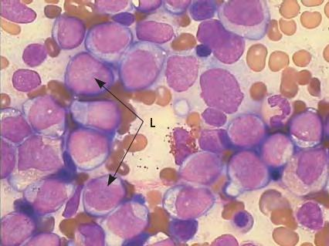

Blood taken in an EDTA container for evaluation should be considered in a similar fashion to a biopsy. In this case, it is a biopsy of a mesenchymal organ called blood but may yield information similar to that obtained from the biopsy of a solid organ.

APPROACH TO THE PAEDIATRIC HAEMATOLOGY PATIENT

In contrast to adults, a parent or carer almost invariably accompanies children.
During the initial period of history-taking and clinical examination it is important to make the child and parent or carer feel relaxed. Observe the child for sweating, cough, dyspnoea and see if he/she is holding a position to protect a limb or other part of body. Is the child alert? Is the child sick? If the parent or carer says the child is sick they are usually correct. It should be stressed that children are not small adults and the history, physical examination and interpretation of the blood results will vary according to the age, race, family history and consanguinity of the child and parents.
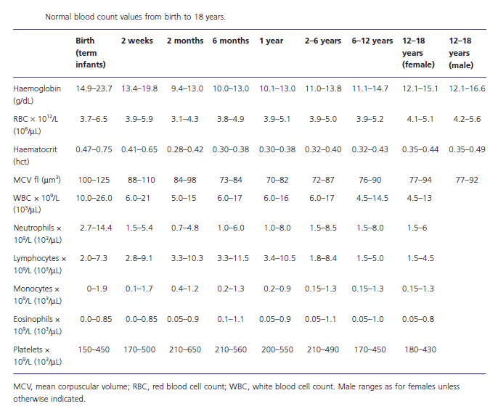

Iron deficiency in adults should lead to an immediate search for blood loss, whereas in children nutritional aspects are far more important. What we see in children is far more likely to be caused by infection, poor nutrition or bleeding than to malignancy or rare disorders such as haemolytic anaemia.

How important is dietary history in assessing the cause of anaemia in children?

Dietary history is very important as it is related to a source of iron. Infants, particularly those delivered pre-maturely, and those consuming large amounts of cow’s milk or formula unsupplemented with iron are at risk of iron deficiency anaemia as are children and adoles cents who consume little meat. A history of pica suggests a possible iron deficiency, lead toxicity or both.

Breastfed infants or mothers who follow a strict vegan diet may become deficient in vitamin B₁₂.

Is it important to ask if the child was jaundiced at birth?

A neonatal history of jaundice (hyperbilirubinanaemia) supports a possible diagnosis of congenital haemolytic anaemia such as hereditary spherocytosis, which is further supported by a family history of anaemia, splenectomy and/or cholecystectomy.

Is it important to ask if the child is taking any medication?

Medication history is pertinent in all patients as certain drugs can induce oxidative haemolysis (an enzymopathy, e.g. G6PD deficiency). Other medications may cause immune haemolysis, such as penicillin, or a decrease in red cell production, as with chloramphenicol, but the latter usually causes pancytopenia. A history of recent travel may suggest exposure to infections such as malaria.

Has the child ever passed red urine?

Haemoglobinuria may provide a clue to the cause of the anaemia. Possible factors include infection, medica-tion and foods (fava beans in G6PD deficiency). Past medical history should enquire about neonatal jaun-dice, recurrent infections, arthritis, rash, mouth ulcers or thyroid disease suggesting autoimmune haemolysis. Family history should include ancestry (African, Medi-terranean or Arab ancestry suggests G6PD deficiency, mainly but not exclusively in males, or sickle cell disease).

Of what importance is the age at which the child first had symptoms or signs?

Patients with α-thalassaemia major are symptomatic in the fetal or neonatal period and are common in South-East Asia, Mediterranean, Middle East, North and West Africa. A family history for iron deficiency that fails to respond to iron may be incorrect and an important pointer to the diagnosis of thalassaemia.

Ask for the patient’s ethnic origin as the thalassaemias, which are usually recessive, are common in South-East Asia, the Mediterranean, Middle East, North and West Africa. A family history of iron deficiency that fails to respond to iron replacement may be incorrect and an important pointer to the diagnosis of thalassaemia.

What is the differential diagnosis in a plethoric child?

A plethoric child will usually have elevated haemoglobin (erythrocytosis). The patient’s age is very important as most children with polycythemia have congenital heart disease or severe lung disease. Symptoms or signs of pul-monary or cardiac disease, such as dyspnoea and cyano-sis, may be critical pointers to the high haemoglobin levels. In neonates it is important to ask about delayed clamping of the umbilical cord, maternal diabetes or other causes of chronic fetal hypoxia. Dehydration is the most common cause of erythrocytosis (polycythaemia) as volume depletion increases the haematocrit. The poly-cythemia is corrected by rehydration.

What should you suspect in a child with recurrent infections?

The presence of unexpected infection affecting the skin, mucus membranes, perineum, lungs and abscess forma-tion and/or failure to thrive suggests that the child may be neutropenic.
Neutropenia is defined as a neutrophil count of <1.5 × 10⁹/L. However, a significant risk of serious infection is usually seen when the neutrophil count is <0.5 × 10⁹/L. In children of African descent the normal neutrophil count is lower than that in Caucasians.

What would you expect to find on clinical examination?

Failure to thrive or recent weight loss can be a presenting feature. Particular attention should be paid to examina-tion of the ears, nose and throat (scarred tympanic membranes, gingivitis and aphthous ulceration, postnatal dip) respiratory tract (recurring cough, wheeze, chest deformity, cervical adenopathy), haemopoietic system (lymphadenopathy, hepatosplenomegaly and pallor) and skin (abscess, especially nail infections). Documentation of fevers is important, but rectal temperatures should be avoided because of the risk of causing Gram-negative bacteraemia.

How may a child present with a possible bleeding disorder?

Bleeding into the skin (petechial purpura/haematomas) from mucosal membranes (epistaxis, menorrhagia) or into joints (haemarthroses) or from the renal tract (hae-maturia) are the most common sites of blood loss in a child with a bleeding disorder.

An incidental abnormal coagulation screen during presurgical screening should always be investigated prior to surgery.

How does the family history help in a child with a suspected bleeding disorder?

A family bleeding history in males suggests haemophilia A or B and the usual pattern consists of deep-seated haematomas or haemarthroses. The most common cause of inherited bleeding disorder in males and females is von Willebrand’s disease where mucosal bleeding, especially nose bleeds and heavy periods (menorrhagia), are the most common manifestations.

What common acquired disorders cause bleeding into the skin (purpura)?

A palpable purpuric rash, usually in the lower limbs, suggests the vasculitis of Henoch–Schönlein purpura. Less well-localized rashes are commonly seen in viral infections, but an acutely ill child with a purpuric rash should be assumed to have meningococcal septicaemia. A purpuric rash, which becomes necrotic, indicates a diagnosis of purpura fulminans caused by viral or bacterial infection secondary to a deficiency of the natural anticoagulant protein C or S.

A non-palpable pruritic generalized rash suggests thrombocytopenia. This may be accompanied by bleeding into mucosal surfaces. A low platelet count does not cause haemarthrosis. In the absence of any other physical finding, such as lymphadenopathy or splenomegaly, a diagnosis of autoimmune thrombocytopenia is most likely. A blood film should always be carefully examined and if the diagnosis is in doubt a bone marrow aspirate should be examined. Children with acute leukaemia may present with purpura, but there are usually other abnor-malities found when a blood film is examined.

In neonates, it should also be emphasized that obtain-ing a detailed maternal history, including bleeding prob-lems, preeclampsia and drug ingestion in the present and past pregnancies and any history of viral infections (cytomegalovirus, rubella, herpes simplex and HIV) or connective tissue disease (systemic lupus erythematosus), will save time and investigations.

What are the common causes of enlarged lymph nodes in children?

Most of the illnesses manifesting with large lymph nodes represent common bacterial and viral infections, and tend to improve spontaneously or after appropriate anti-biotic use. At the same time, enlarged lymph nodes can be an initial sign of a childhood malignancy.

How can the history help?

The character and time-course of the adenopathy are important. A rapid onset of unilateral groin adenopathy following trauma to the lower extremity suggests infec-tion. In contrast, generalized adenopathy that has appeared over time in association with weight loss, fevers and night sweats suggest a haematological malig-nancy (lymphoma/leukaemia) or an infection such as tuberculosis.

As in adults, tender lymphadenopathy in children is usually associated with an infective or inflammatory reaction while non-tender rubbery lymph node enlargement is more often seen with a malignant process.

Is the age of the child important when considering the differential diagnosis?

The age of the child with lymphadenopathy has a bearing on the differential diagnosis. It is extremely rare to see malignancy in neonates compared to older children and young adolescents. Lymphadenopathy in the neonatal period is most likely secondary to viral infections.

How important is the family and travel history in helping to make a diagnosis?

Family history should include place of birth and recent travel, the latter to determine whether the child has been exposed to geographical areas with high rates of infec-tion such as kala azar, tuberculosis or histoplasmosis. There may be a family history of HIV infection or tuberculosis.

What other questions may be relevant?

Always ask about pets. If there are animals in the house-hold they may play a significant part in the lymphade-nopathy. The presence of cats or kittens (cat scratch fever, toxoplasmosis) which scratch the child are often omitted from the parent’s history of the patient unless such questions are specifically asked.

