Abnormalities of the pelvis, macrosomy
Contracted pelvis
- A state that alteration in size and/or shape of the pelvis of sufficient degree so as to alter the normal mechanism of labour in an average size baby.
- Anatomically contracted pelvis all or one of its dimensions are reduced by 1.5-2 cm compared to the norm
Etiology of contracted pelvis
- Rickets
- Polio
- Tuberculosis
- Trauma
- Tumors of pelvic bones
- Metabolic disorders
- Malnutrition
- Hip joints disease
- Kyphosis, scoliosis
Anatomically contracted pelvis
- Are determined by the true conjugate
- I degree – 11-9 cm (if the fetus is small, childbirth can end without assistance)
- II degree – 9-7.5 cm (significant complications in childbirth)
- III degree – 7.5-6 cm (birth thropugh the natural birth canal is impossible, only CS or embryotomy)
- IV degree – less than 6 cm (only CS, even in case of dead fetus)
Abnormalities of the pelvis form
Common types:
- Justo minor pelvis – a pelvis, all of the dimensions are reduced by 1.5-2 cm
- Flat pelvis (the anterior posterior dimensions are reduced)
- Simple flat pelvis (all reduced direct dimensions)
- Flat rachitic pelvis (reduced direct dimension of the area of brim)
- Generally contracted flat pelvis (all the dimensions are reduced, especially anterior-posterior)
Abnormalities of the pelvis form
Rare forms:
- Obliquely oval pelvis ( decreased lower oblique dimensions on one side)
- Funnel-shaped pelvis
- Osteomalacic (breaked) pelvis
- Spondylolisthetic pelvis
- Assimilating pelvis
- Kyphotic pelvis
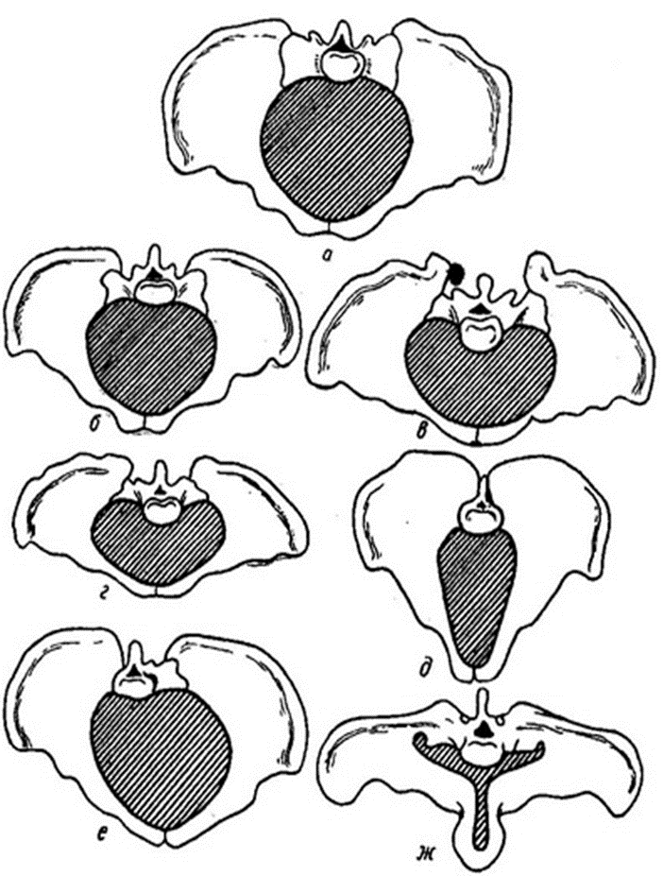
Forms of contracted pelvis:
а-normal pelvis
б- generally contracted pelvis
в – flat pelvis
г – generally contracted flat pelvis
д-transversely contracted pelvis
е – obliquely contracted pelvis
ж - osteomalacic (breaked) pelvis
Diagnosis
- Past history : fractures, rickets, tuberculosis, polyomyelitis, abstetrical – previous safe vaginal delivery, weight of the previous babies, evidences of maternal injuries.
- Physical examination: the height of the woman, deformities of pelvic bones, hip joints, spine
- Abdominal examination: pendulous abdomen, especially in primigravidae, presence of malpresentations in primigravidae, clinical pelviometry
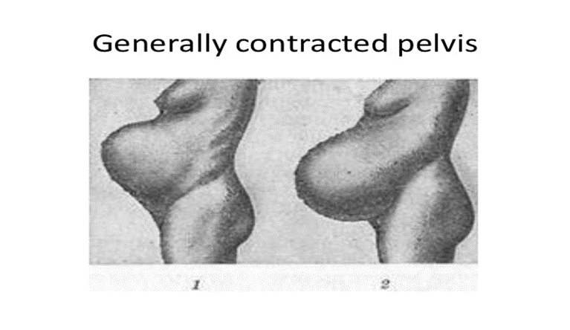
Management of labour
- In case of I and II stages of contracted pelvis, the trial labour should be tried, in case of III and IV stages, the birth of a live fetus is impossible.
- The prognosis of labour depends on the measurements of the pelvis, the measurements of the fetal head, the type of fetal head engagement, configuration of the head, characted of labour activity, state of placental-maternal blood circulation
Peculiarities of biomechanism of labour in justo minor pelvis
- Maximum flexion and engaging the head with its sagittal suture into one of the oblique dimensions with the dimension of the head less than small oblique
- Maximum flexion of the fetal head due to configuration
- Dolichocephalic form of the fetal head due to configuration
Labour lasts longer than in case of a normal pelvis, is often accompanied by birth trauma
- Peculiarities of biomechanism of labour in simple flat pelvis
- This is a pelvis where all the anterior-posterior sizes are reduced, for example 26,29,31,18
- The high and long duration of the head above the pelvic plane of inlet
- Engaging of the head into the brim with sagittal suture in the transverse size, often asynclitic fitting, mostly anterior
- Descending of the head with its sagittal suture in the transverse diameter up to the pelvic plane of least dimensions (low transverse standing head of the fetus)
Biomechanism of labour in flat rachitic pelvis
- The mechanism of labour goes according to the flat or generally contracted pelvis
- Complications of labour in contracted pelvis
- Late or preterm discharge of amniotic fluid
- Prolapse of loops of umbilical cord and small parts of the fetus
- Incorrect engagement of the fetal head
- Abnormalities of uterine activity
- Trauma of maternal passages
- Injuries of the fetus
Clinically contracted pelvis
- They include all incidences of disproportion between the fetal head and maternal pelvis, not depending on the measurements of the pelvis.
- The disparity in the relation between the head and the pelvis is called cephalopelvic disproportion
- Etiology – anatomically contracted pelvis, big baby (hydrocephalus), post term pregnancy, fetal tumors and malformations, deflexion presentation of the head of the fetus
Diagnosis
- History taking
- Pelviometry
- Precise external obstetrical examination, especially during conducting the third and fourth Leopold maneuver
- The measurement of the expectant weight of the baby
- The diagnosis of the Henkel-Vasten’s sign
- The dilation of the cervix should be at least 8 cm
- Lack of descending of fetal head in case of normal uterine contractile activity
- Bearing down efforts with fetal head positioned high above the pelvic plane of inlet
- Absence of membranes
- Empty urinary bladder
- Normal contractile activity of the uterus
Henckel-Wasten’s sign
Positive (а) – the head surface is above the surface of the symphysis
At level (б) – front surface of the fetal head is at level of the symphysis
Negative (в) – front surface of the head is placed below the plane of the symphysis
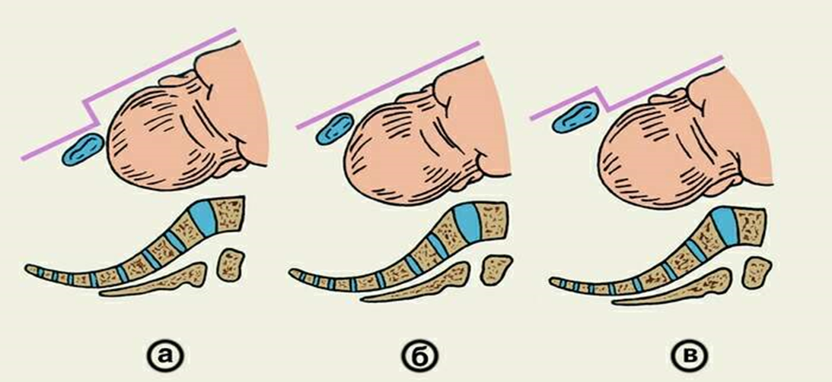
Diagnosis
The symptoms of the threatening uterine rupture are noticed in case of severe disproportion between the pelvis and the fetal head. That is over distention and painful low segment of the uterus, high location of the contraction ring, the symptoms of cervix pressure, its edema, that spread of the external genitalia.
Big fetus
A big fetus is a fetus 4000g or more (up to 5000g), a fetus more than 5000g is called gigantic
The rate 8-10 % of all the labours
Etiology – genetic, increased intake of the carbohydrates, diabetes mellitus.
Diagnosis of the big fetus
History (the height and the weight of the husband, the weight of the pregnant at birth, the weight of the babies at previous deliveries, diabetes mellitus of the pregnant or other endocrinological diseases.
Objective examination: the circumference of the abdomen more than 100 cm, the height of the uterus more than 40cm, the size of the fetal head by palpation, the measurement of the fetal head by the ultrasound, ultrasound measurement of the pelvis
The course of pregnancy in case of big fetus
The course of pregnancy does not significantly differ from the physiological pregnancy, but sometimes to the high position of the diaphragm dispnoae may be present
The course of labour in case of big fetus
The course of labour due to over distension of the uterus and disproportion of the fetal head quite often are complicated by the not on time dischargment of the amniotic fluid, primary and secondary uterine inertia.
In case of disproportion of the pelvis and the head, the labour course is alike the labour in case of clinically contracted pelvis
Because of the pressure of the big head by the bony part of the birth canal, fetal distress, intracranial trauma may occur
Labour management in case of big fetus
After the fetal head is born, quite often the complicated labour of the shoulders may be seen, especially in case of diabetes mellitus of the pregnant, when the shoulders dimensions are more that the diameters of the head.
In the III rd stage of labour and postpartum period quite often the complications due to over distension of the uterus may be present: the complications of the separation of the placenta, hypotonic haemorrhage. In case of labour with a big fetus, the rate of birth trauma of the birth canal, uterus, vagina and perineum increase.
Prophylaxes of the big fetus
Its hard to do the prophylaxes of the big fetus, the precise evaluation of the obstetrical situation should be done. IN case of complications (contracted pelvis, breech presentation, elderly primigravida) cesarean section should be performed
In case of vaginal delivery, the on time diagnosis of the disproportion of the pelvis and the fetal head should be diagnosed.

